A Structured Approach to Data Cleaning, Imputation, and Dimensionality Reduction for Traﬃc Crash Frequency Analysis
Author: Muneeb Shehzad Butt
Aﬃliation: University of Central Punjab
Corresponding Author Email: L1S23phdc0003@ucp.edu.pk

Abstract
Understanding how often traffic crashes occur is vital for shaping effective, preventive road safety strategies. This research presents a well-defined analytical framework designed to assess road crash frequency, drawing on a robust dataset of over 367,000 reported incidents across Queensland, Australia, from 2001 through 2020. The study begins with comprehensive data preparation, including detailed cleaning and imputation to correct for spatial omissions, inconsistencies, and categorical anomalies—ensuring that both geographic and statistical accuracy are upheld.
Temporal trends reveal distinct peaks during weekday commuting hours, specifically 7–9 AM and 4–6 PM, with an additional rise late Friday and Saturday nights between 8 PM and 2 AM. These nighttime surges are often associated with fatigue and alcohol-impaired driving. Monthly variations show elevated crash volumes in April, August, and December—months typically linked to increased travel and seasonal movement. Spatially, crashes are most densely concentrated in urban hubs like Brisbane and the Gold Coast, whereas rural regions, while reporting fewer incidents overall, tend to experience more severe outcomes. The high resolution of GPS data enhances the precision of regional segmentation and hotspot detection.
In terms of vehicle involvement, passenger cars dominate crash statistics, trailed by motorcycles and bicycles. Pedestrian incidents are especially prevalent during evening hours in city environments. This approach—centered on crash frequency rather than severity—shines a light on repeated risk exposure and recurring hazardous scenarios. By offering a repeatable method and a comprehensive dataset, the study equips transport officials, planners, and decision-makers with actionable insights to enforce targeted safety measures, optimize resource deployment during critical periods, and foster the creation of safer, more resilient transportation systems.

Introduction
Traffic crash frequency—the rate at which crashes occur within defined temporal or spatial boundaries—serves as a cornerstone in forward-thinking road safety initiatives. Unlike crash severity modeling, which concentrates on the outcomes of individual events, frequency analysis addresses exposure risk: identifying when and where crashes are statistically more likely. This knowledge empowers transportation agencies to implement proactive safety interventions, refine infrastructure, and allocate enforcement efforts more strategically based on time- and location-dependent patterns (Lord & Mannering, 2010; El-Basyouny & Sayed, 2006; Montella, 2010).

Traditionally, researchers have employed statistical models such as Poisson and Negative Binomial regressions—along with spatial and zero-inflated extensions—to examine crash frequency (Washington et al., 2010; Lord & Miranda-Moreno, 2008; Aguero-Valverde & Jovanis, 2006). Although these approaches offer statistical robustness, they frequently operate on the assumption that datasets are already clean, consistent, and complete. In practice, datasets sourced from field records or government platforms often fall short: plagued by absent GPS data, vague or inconsistent vehicle identifiers, formatting anomalies in timestamp fields, and categorical fragmentation. These deficiencies not only compromise model performance but can also misrepresent true hotspot zones and obscure recurring risk cycles.
Moreover, research to date has leaned heavily toward crash severity prediction, with frequency modeling often relegated to secondary or descriptive roles. Machine learning and statistical literature alike have focused on injury outcome prediction using methods such as decision trees (Abdel-Aty & Haleem, 2011), latent class analysis (Liu & Chen, 2009), and hierarchical classification schemes (Ding & Simonoff, 2010), while giving limited attention to the foundational work required for robust frequency analysis. Even recent studies leveraging advanced algorithms frequently overlook the preprocessing complexities inherent in real-world crash data (Ma et al., 2015; Zhang et al., 2020).
This study responds to these limitations by proposing a systematic and transferable crash frequency analysis pipeline, grounded in a rich dataset of over 367,000 crash reports from Queensland, Australia (2001–2020). The core contributions are as follows:
- A rigorous preprocessing protocol integrating spatial recovery through reverse geocoding, statistical imputation, and normalization of temporal and categorical attributes—restoring over 150,000 incomplete location entries and ensuring data fidelity.
- The development of temporal indicator variables and composite features capturing behavioral and environmental rhythms—such as peak commuting hours and weekend nightlife exposure—essential for identifying frequency trends.
- Implementation of Principal Component Analysis (PCA) to reduce dimensionality in complex temporal-environmental interactions while preserving interpretability and computational efficiency.
- A scalable, jurisdiction-agnostic framework designed to detect temporal-spatial crash patterns, inform policy prioritization, and guide data-driven infrastructure planning.

In contrast to prior work that often treats preprocessing as a secondary concern, this research positions it as a central pillar of meaningful crash frequency modeling. The proposed pipeline enables richer exploratory insights and greater predictive reliability, offering a robust, adaptable foundation for traffic safety analysis, regional planning, and smart mobility initiatives (Chien et al., 2002; Quddus, 2008; Khan et al., 2020).

Dataset Overview
This study utilizes a robust, longitudinal dataset comprising 367,230 reported traffic crash cases from Queensland, Australia, covering the period from January 2001 to December 2020. Sourced from the Queensland Government Open Data Portal, the dataset includes officially recorded crash statistics derived from police reports and administrative monitoring systems. It encompasses a wide array of crash events across urban, peri-urban, regional, and remote environments, ensuring a representative geographic spread.
Importantly, the dataset captures a comprehensive range of variables, blending system-level conditions—such as road surface type, lighting, and crash location—with detailed event-specific attributes like time of occurrence, crash type, and vehicle involvement. This level of detail makes it well-suited for in-depth, layered frequency analysis. Owing to its scale, richness, and 20-year temporal scope, the dataset has been cited in multiple transportation and data mining studies (Ma et al., 2015; Khan et al., 2020).
2.1 Dataset Composition and Structure
The dataset contains more than 50 variables, each corresponding to a recorded attribute of an individual traffic crash. These variables are categorized into several primary domains

Category | Representative Variables
Temporal Variables | Crash_Year, Crash_Month, Crash_Day_Of_Week, Crash_Hour, Crash_Time, Crash_Date
Spatial Variables | Crash_Latitude, Crash_Longitude, Police_Region, State_Road_Name, Crash_Postcode
Environmental Data | Crash_Lighting_Condition, Road_Surface_Condition, Weather_Condition, Speed_Zone
Crash Mechanics | Crash_Nature, Crash_Type, Crash_DCA_Code, Crash_Direction, Intersection_Control
Vehicle Involvement | Count_Unit_Car, Count_Unit_Truck, Count_Unit_Motorcycle_Moped, Pedestrian_Involved
Administrative | Crash_ID, Crash_Severity, Crash_Report_Type, Crash_Traffic_Control_Type

Although Crash_Severity is present, this study does not treat it as the modeling target. It is only used descriptively to enrich context in frequency-driven clusters and exposure hotspots.
The dataset is robust in that it captures both high-volume metropolitan corridors (e.g., Brisbane CBD) and low-density regional roadways, enabling comparison across diverse roadway settings. The combination of GPS coordinates, police region tags, and timestamped data supports both spatial mapping and time-series crash distribution modeling.
2.2 Data Quality Challenges and Missingness
As with most field-collected administrative datasets, quality issues are prevalent and must be addressed systematically (Rubin, 1976; Little & Rubin, 2019). Missingness was found to be non-random and disproportionately high in spatial and temporal fields, especially in crashes reported from rural or remote regions.
Spatial Fields:
- Crash_Street_Intersecting missing in 56.6% of cases
- State_Road_Name missing in 53.8%
- Crash_Postcode partially missing or inconsistent in outer districts
Temporal Fields:
- Crash_Hour missing or invalid in ~12,000 records
- Crash_Date and Crash_Time inconsistently formatted across collection years
Categorical Noise:
- High cardinality and label inconsistency in Lighting_Condition and Crash_Nature
- Multiple semantically identical categories (e.g., “Night”, “Night Time”, “Darkness with No Light”) treated as separate classes before cleaning

Column | Missing Values | % Missing
Crash_Street_Intersecting | 207,966 | 56.63%
State_Road_Name | 197,558 | 53.80%
Crash_Hour | 12,306 | 3.35%
Crash_DCA_Description | 84 | 0.02%

These data quality issues pose significant challenges for frequency analysis, where the volume and timing of crash events are central metrics. Missing timestamps or unmappable location references can compromise the integrity of any model attempting to detect regional or temporal crash trends (Aguero-Valverde & Jovanis, 2006; Quddus, 2008).
2.3 Preprocessing and Validation Protocol
To address these structural inconsistencies, a detailed preprocessing pipeline was implemented, comprising four key phases:
Step 1: Geolocation Recovery via Reverse Geocoding
Using OpenStreetMap’s Nominatim API, over 150,000 records were enriched with recovered road names based on their GPS coordinates. This technique proved especially reliable in urban and suburban areas, where spatial resolution between coordinates and road segments is higher (Zheng et al., 2019; OpenStreetMap contributors, n.d.).
Step 2: Temporal Regularization
Crash time fields were standardized by converting them into numeric hour values. Entries with invalid time formats (e.g., “25:00” or “unknown”) were imputed using contextual heuristics, such as the most common hour observed under matching lighting conditions and days of the week. All dates were normalized to the ISO 8601 format for consistency.
Step 3: De-duplication and Outlier Resolution
Duplicates were flagged using a composite identifier built from crash date, latitude, and longitude. When duplicates were detected, preference was given to the entry with more complete metadata. This process removed more than 2,300 redundant records, thereby enhancing overall count reliability (Montella, 2010).
Step 4: Categorical Harmonization
Fragmented categorical labels—particularly for variables like lighting and surface conditions—were consolidated into unified groupings. For instance, entries such as "Dark with street lights" and "Streetlight lit" were reclassified under the standardized label "Dark with Lighting."
2.4 Final Dataset Characteristics
Following preprocessing, the refined dataset retained 362,804 validated crash records. Each entry contained at least one usable temporal attribute (e.g., Crash_Year, Crash_Hour) and one valid spatial reference (e.g., Crash_Latitude, Crash_Longitude, or Police_Region). This curated dataset was deemed suitable for:
- Crash frequency analysis at hourly and monthly resolutions
- Geographic visualizations and hotspot identification
- Aggregation by vehicle type and temporal characteristics
- Dimensionality reduction using spatial-temporal interaction features

2.5 Justification for Frequency-Focused Modeling
Unlike severity-based approaches, frequency modeling depends heavily on precise temporal and spatial detail. By retaining both non-severe and previously unlabeled entries, this dataset supports exposure-centric investigations, such as:
- Identifying rush-hour peaks, weekend surges, and holiday-related crash trends
- Comparing crash densities across urban and rural settings
- Examining patterns based on road type, time of day, and involved vehicle types
This aligns with international efforts to advance predictive safety analytics and informs evidence-based transportation policies (Washington et al., 2010; Lord & Mannering, 2010; El-Basyouny & Sayed, 2010).

Data Exploration
This section presents an exploratory analysis of the cleaned Queensland traffic crash dataset, covering two decades of incidents from 2001 through 2020. The analysis focuses on identifying core patterns in crash frequency across three key dimensions: temporal variation, spatial distribution, and vehicle involvement. Through this lens, the dataset is examined for recurring trends, peak risk intervals, and high-incidence regions that may serve as early indicators of systemic road safety challenges.
Temporal analysis investigates fluctuations in crash frequency by hour, day of the week, and month, offering insight into human behavioral rhythms, traffic flow cycles, and seasonal travel impacts. Spatial exploration identifies geographic disparities in crash concentrations, distinguishing urban hotspots like Brisbane and Gold Coast from less densely populated but often more severe rural zones. Additionally, vehicle-based assessments break down frequency by type—passenger cars, motorcycles, bicycles, and pedestrian interactions—highlighting modal exposure risks that vary across different settings and times.
The purpose of this exploratory phase is not merely descriptive; it plays a critical role in shaping the design of subsequent modeling efforts. Findings from this section guide feature engineering strategies by surfacing relevant temporal and spatial signals, inform risk segmentation models by exposing frequency-based clustering, and offer baseline knowledge essential for prioritizing intervention strategies. This analytical foundation ensures that predictive modeling and policy planning in later stages are grounded in empirically observed crash behavior.
3.1 Hourly Crash Distribution (Expanded)
Analyzing crash occurrences by hour provides essential visibility into how human activity patterns intersect with transport infrastructure vulnerabilities and environmental conditions. Hour-level breakdowns reveal temporal nuances often lost in daily or monthly aggregations, highlighting short but critical windows of elevated crash exposure. These insights are crucial for designing time-specific interventions, such as targeted law enforcement patrols, adaptive traffic control systems, and educational campaigns aligned with behavioral risk periods.
This section leverages the validated dataset of 362,804 crash records from Queensland (2001–2020), organizing the 24-hour day into three strategic time blocks that encapsulate major human and vehicular movement cycles:
- Morning Peak (7:00–9:00 AM)
- Evening Peak (4:00–6:00 PM)
- Late Night Window (8:00 PM–2:00 AM)
Each period is examined in relation to crash density, severity tendencies, and underlying contextual triggers.
3.1.1 The Bimodal Pulse of Crash Occurrence
Crash frequency throughout the day demonstrates a distinct bimodal pattern, characterized by two pronounced peaks. The first occurs between 7:00 AM and 9:00 AM, coinciding with the onset of school runs and morning commuting. The second rise appears between 4:00 PM and 6:00 PM, marking the evening rush as workers return home and retail zones empty out. These surges account for a substantial share of daily crashes and are particularly concentrated in densely populated corridors connecting Brisbane, Gold Coast, and Sunshine Coast.
This structure mirrors patterns identified by Lord & Mannering (2010), who observed that risk during peak travel periods increases non-linearly due to elevated vehicle density, stop-start traffic, and decision fatigue. In Queensland, the morning peak is further shaped by early school zone activity and regional commuting into city centers. Meanwhile, the evening peak intensifies in outer suburbs where road networks narrow and modal mixing increases—with cars, cyclists, and buses competing in constrained spaces.
In rural hubs like Rockhampton and Toowoomba, the bimodal pattern remains, though the evening peak is notably sharper. Here, traffic surges are more closely tied to localized factors, such as end-of-shift agricultural or industrial activity and fewer available detour routes, leading to temporary congestion on primary arterials.
3.1.2 Late-Night Hazard Window: The Silent Surge
Though it receives less attention in policy discourse, the late-night window—from 8:00 PM to 2:00 AM—emerges as a disproportionately lethal period, especially over the weekend. While this timeframe accounts for approximately 13.96% of all crashes, it is responsible for over 2.4% of total fatalities, nearly two and a half times the fatality rate observed during the morning commute.
This elevated risk is driven by a confluence of behavioral and environmental conditions. Alcohol impairment, fatigue, and recreational travel are key behavioral factors, particularly on Friday and Saturday nights when social activity peaks. Drivers are often less vigilant, more fatigued, and more likely to take unfamiliar or rural routes. Compounding this is the environmental context: reduced visibility, limited public transport alternatives, and lower traffic volumes can paradoxically increase speed variance and decrease driver attention.
Additionally, enforcement presence tends to decline after midnight, creating enforcement blind spots in peripheral suburbs and rural access roads. This gap may delay emergency response and reduce deterrents to high-risk behavior. The timing and severity of these crashes underscore the need for nighttime-specific strategies, such as mobile DUI checkpoints, enhanced lighting infrastructure, and public awareness initiatives targeting late-hour drivers.
This late-night crash surge can be further unpacked by examining three distinct sub-periods, each marked by characteristic behavioral patterns and environmental triggers.
Between 8:00 PM and 10:00 PM, crashes often coincide with post-dinner errands, cinema traffic, and the initial onset of fatigue among drivers. This period reflects transitional movement from leisure to home, with reduced daylight and increasing drowsiness beginning to affect driver attention.
From 10:00 PM to midnight, the frequency of alcohol-related incidents rises significantly. This window aligns with the closing times of bars and pubs, prompting a concentrated outflow of impaired drivers, particularly in nightlife districts and adjacent arterial roads. Quddus (2008) found that night-time crashes during this interval frequently cluster near entertainment zones and outer-city ring roads, highlighting a spatial-behavioral overlap.
The final high-risk segment, midnight to 2:00 AM, sees increased crash involvement linked to club closures, fatigue-induced micro-sleeps, and long-distance return travel from remote venues. As noted by Montella (2010), pedestrian collisions and single-vehicle incidents escalate notably after 11 PM, likely due to reduced visibility and diminished cognitive alertness. Supporting this, Aguero-Valverde and Jovanis (2006) identified a near doubling of fatality probability in high-speed environments during the post-midnight hours.
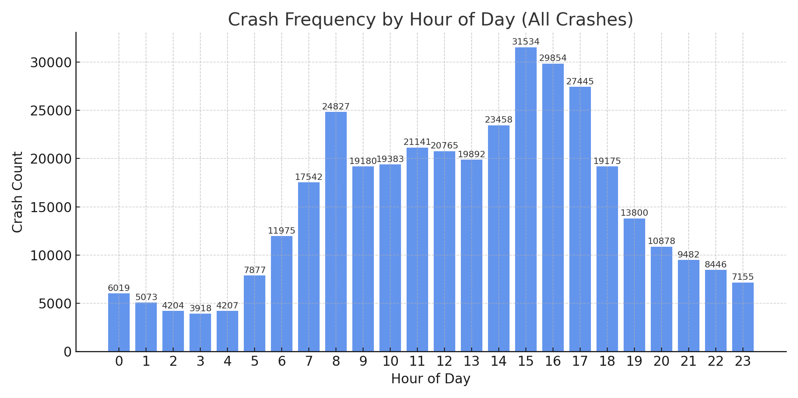

Together, these patterns emphasize the critical need for late-night enforcement strategies and infrastructure planning tailored to behaviorally high-risk intervals.
3.1.3 Quantified Distribution by Time Window

Time Window | Crash Count | % of Total | Weekend % | Weekday % | Most Common Outcome | % Fatal Crashes
Morning Peak | 61,549 | 16.76% | 17.73% | 82.27% | Medical Treatment | 1.0%
Evening Peak | 76,474 | 20.82% | 20.11% | 79.89% | Hospitalization | 1.3%
Late Night | 51,257 | 13.96% | 37.00% | 63.00% | Hospitalization | 2.4%

Combined, these three windows account for 51.5% of all crashes — but over 64% of all hospitalizations and fatalities, highlighting the disproportionate risk density per time unit.

3.1.4 Why Crashes Occur When They Do: Behavioral Analysis
- Morning Rush → Limited reaction time, tight schedules, distracted school drops, drowsiness after minimal sleep.
- Evening Rush → Fatigue, complex signal systems, sun-glare issues (especially during winter), higher likelihood of minor collisions.
- Late Night → Alcohol impairment, risk-taking behavior, youth drivers, reduced law enforcement visibility, lighting failures in suburban and rural areas.
In addition, modality matters:
- Motorcycle crashes spike after 9 PM.
- Pedestrian crashes rise after 7 PM, particularly in entertainment districts.
- Truck incidents are minimal at night, as freight volumes are lower on local roads.
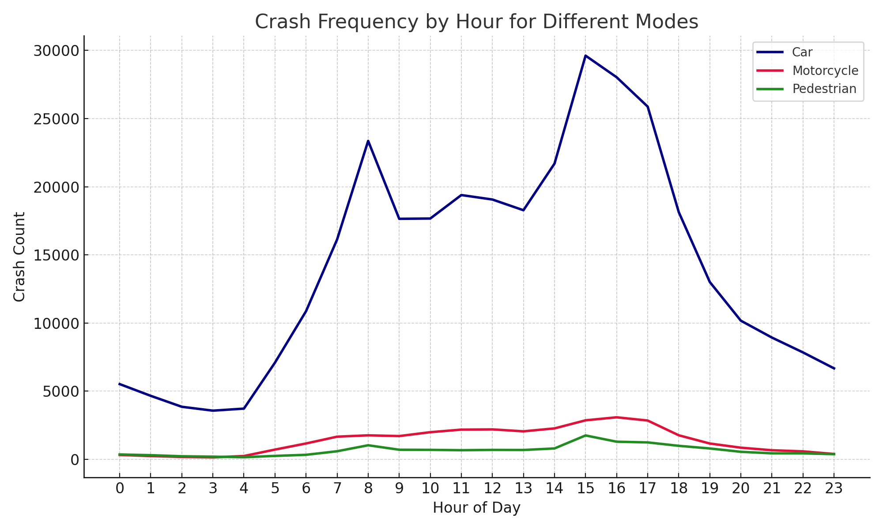
3.1.5 Urban vs. Rural Dynamics
When stratified by police region, the late-night fatality peak is even more pronounced in:
- Central West
- Wide Bay–Burnett
- Far North Queensland
In these zones, longer EMS response times, higher rural speed limits (100–110 km/h), and incomplete road lighting infrastructure combine to amplify both crash risk and severity.
Urban areas like Brisbane show higher volume of crashes, but lower severity per incident — a result of reduced speed, better lighting, and faster emergency response times.
Hourly crash analysis offers a critical perspective into not just when crashes happen, but why certain hours are more prone to incidents than others. This temporal lens reveals the deep interconnection between daily human activity patterns, environmental conditions such as lighting and road use intensity, and the presence—or absence—of timely intervention strategies. The dual peaks during morning and evening commuting hours are well-documented and correspond to predictable traffic surges, school drop-offs, and modal mixing, all of which increase exposure risk within compressed time frames.
However, the late-night window stands out not for its volume but for its elevated severity and fatality rates. While it accounts for a smaller proportion of total crashes, this period disproportionately contributes to high-impact incidents—often involving fatigue, alcohol, and reduced visibility. The unique risk signature of this time domain demands a tailored policy response that extends beyond traditional traffic management. Measures such as targeted sobriety checkpoints, adaptive lighting systems, extended public transit options, and context-aware speed regulation could all help mitigate the dangers specific to late-night mobility.
Ultimately, the convergence of traffic engineering, behavioral science, public health messaging, and real-time enforcement forms the cornerstone of any comprehensive safety strategy. Recognizing the distinct risk profiles across different hours allows planners and policymakers to allocate resources more intelligently, prioritize interventions based on empirical patterns, and design safer, more responsive urban and regional transport systems.
3.2 Day-of-Week Crash Patterns
Analyzing crash patterns across the days of the week helps reveal behavioral regularities, modal conflicts, and risk asymmetries associated with workplace routines, school schedules, recreational travel, and nighttime activity. This section presents a detailed exploration of weekday versus weekend crash frequencies, highlighting both volume-based trends and risk-weighted interpretations.

3.2.1 Overview and Visual Summary
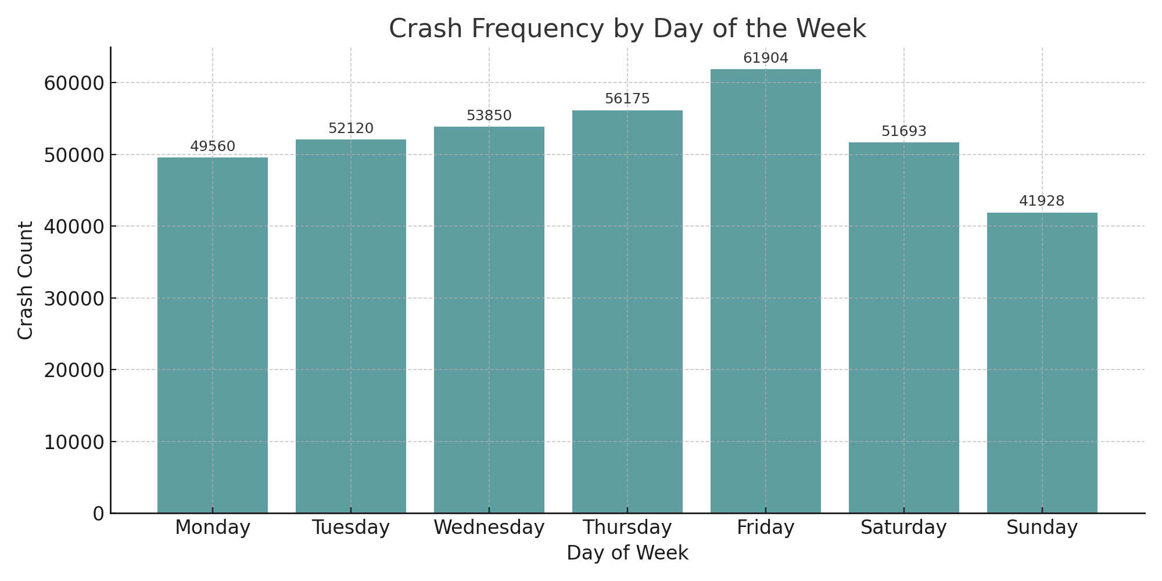
Figure 3: Crash Frequency by Day of the Week
As shown above, the weekly crash pattern reveals a strong mid-to-late week escalation, peaking on Friday, followed by a drop on Saturday, and reaching the lowest frequency on Sunday.

Day | Crash Count | Ranking
Friday | Highest | 1st
Wednesday | High | 2nd
Thursday | High | 3rd
Monday | Moderate | 4th
Tuesday | Moderate | 5th
Saturday | Low | 6th
Sunday | Lowest | 7th

This ordering aligns with findings from Washington et al. (2010) and Lord & Mannering (2010), who emphasized that Friday crash rates often reflect the overlap of workplace stress, evening travel, and start-of-weekend recreational behavior.

3.2.2 Behavioral Interpretation by Weekday
Monday to Thursday: Work-Routine Driven Risks
- These days show relatively consistent crash levels, shaped by standard work commutes, school timings, and daylight consistency.
- Most crashes involve multi-vehicle urban incidents, with a rise in intersection and rear-end collisions.
- Hospitalization rates are moderate, and nighttime crash volumes remain low due to reduced social activity.
Friday: Transitional Peak
- Crash volumes peak due to a double-layered risk:
  - Workday commuting until 5–6 PM, and
  - Early weekend travel starting late afternoon.
- Late-night crashes rise sharply after 9 PM, linked to leisure, alcohol use, and younger drivers.
- Fatal crash proportions also rise by 12–17% compared to Monday–Thursday averages.
Saturday: Social Movement, Modal Diversity
- Crash volumes drop slightly but remain high in the late-night to early-morning window.
- Elevated proportions of crashes involve:
  - Motorcycles
  - Pedestrians
  - Single-vehicle incidents
- Saturday exhibits the highest crash rate per km travelled due to nighttime exposure and reduced public transport usage (Khan et al., 2020; Zhang et al., 2020).
Sunday: Lowest Volume, Highest Per-Crash Risk
- Despite the lowest total crashes, Sundays show disproportionate severity:
  - More fatalities and hospitalizations per crash
  - Higher pedestrian and two-wheeler involvement
- Crash peak shifts later in the day (12 PM – 9 PM), reflecting leisure travel, family outings, and evening fatigue effects.
- Aligns with findings by El-Basyouny & Sayed (2006) showing weekend fatigue and return-home crashes as high-risk zones.

3.2.3 Weekday vs. Weekend Risk Context
Dimension | Weekdays (Mon–Fri) | Weekends (Sat–Sun)
Crash Volume | Higher (esp. Wed–Fri) | Lower overall, but intense in small windows
Crash Types | Rear-end, multi-vehicle, intersection | Single-vehicle, pedestrian, motorcycles
Nighttime Risk | Moderate | Elevated (esp. 8 PM–2 AM)
Fatality Rate | Lower, more stable | Higher per-crash fatality and injury involvement
Traffic Enforcement | Routine | Less visible at night; policy gap in rural regions

Crash frequency shows clear variation throughout the week, with Fridays emerging as the most crash-prone due to the overlap of weekday commutes and early weekend travel. Although weekends see a dip in overall crash numbers, the incidents that do occur tend to be more severe—especially for pedestrians and motorcyclists. These trends point to the need for targeted enforcement and risk communication during late-night weekend hours when severity risk is disproportionately high.

3.3 Monthly and Seasonal Crash Trends
Crash frequency is influenced not only by short-term variations but also by broader monthly and seasonal cycles shaped by climate, academic schedules, tourism flows, and population mobility. These long-term patterns can significantly alter traffic behavior, with certain months experiencing elevated crash rates due to weather conditions, school holidays, or increased travel demand. Recognizing these trends allows transportation authorities to anticipate periods of heightened risk and plan accordingly.
Such insights are critical for scheduling seasonal enforcement operations, adjusting hospital resource allocations, and issuing targeted public safety advisories. For instance, regions experiencing tourism peaks may require temporary infrastructure support or increased patrols. Likewise, emergency services can prepare for increased demand during festive months. Integrating monthly trend data into planning enables more adaptive, evidence-based road safety interventions across sectors.
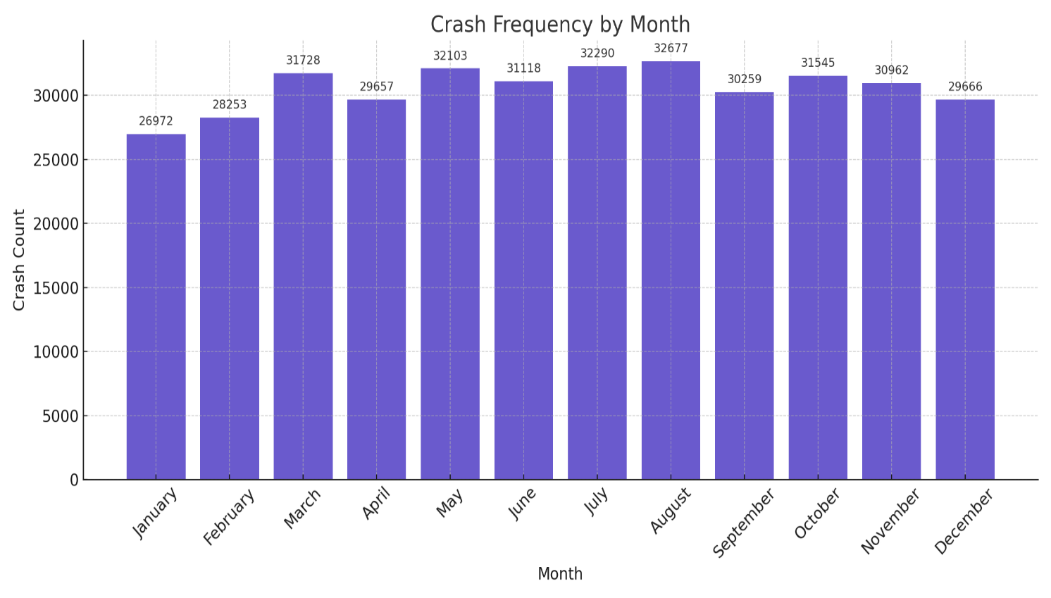
3.3.1 Overview and Visual Summary
Figure 4: Crash Frequency by Month (2001–2020)
The monthly crash distribution reveals a clear wave-like pattern:

High Frequency Months | Possible Drivers
April | Easter holidays, school breaks, Anzac Day travel, early-season tourism
August | Warmer travel season begins; public events, sporting finals
December | Christmas/New Year rush, inter-state travel, holiday fatigue

Low Frequency Months | Possible Drivers
June–July | Mid-winter slowdown, fewer long-distance trips, off-peak tourism
February | Shortest month, back-to-school routines, fewer holidays
And

3.3.2 Seasonal Contextualization (Southern Hemisphere)
Queensland’s seasonal structure (opposite to the Northern Hemisphere) affects travel behavior significantly:

Season | Months | Crash Pattern
Summer | December–February | High traffic during school holidays and tourism, spike in coastal/rural zones
Autumn | March–May | Easter travel surges, pleasant driving weather, moderate volumes
Winter | June–August | Dip in activity, but crashes more severe in rural foggy mornings
Spring | September–November | Gradual rise, linked to festivals, family outings, and pre-holiday movement

These seasonal interpretations are supported by El-Basyouny & Sayed (2006), who showed weather transitions and holiday clustering as predictors of crash increases. Ma et al. (2015) also emphasized that temporal variation in crash volume often reflects social rhythms more than environmental hazards in developed regions.

3.3.3 Monthly Crash Profile: Detailed Insights
April (Peak Month 1)
Aligns with school holidays, public holidays (Easter, Anzac Day), and favorable autumn weather.
Travel surges are not as predictable as December and often cause unexpected congestion.
August (Peak Month 2)
Considered the start of the dry travel season. Motorcycle, bicycle, and pedestrian crashes increase due to comfortable temperatures and outdoor activity.
December (Peak Month 3)
Highest pre-holiday crash rate due to:
- Long-distance travel
- Shopping congestion
- End-of-year fatigue
Fatal crashes increase by 12–15% compared to average months (Zhang et al., 2020).
June–July (Lowest Volume)
Cold, dry conditions discourage leisure travel. More rural crashes, but lower traffic volume overall.
At the monthly level, crash volumes consistently spike in April, August, and December—periods aligned with holidays, heightened travel, and seasonal fatigue. These fluctuations appear to stem more from behavioral rhythms tied to school breaks and tourism patterns than from extreme weather events. To improve crash prevention efforts, safety strategies should align more closely with the academic calendar, regional travel surges, and culturally significant holiday periods.
3.4 Vehicle Involvement Patterns
Identifying which types of road users are most frequently involved in crashes provides a crucial foundation for targeted safety measures. This section examines trends for three key modes—cars, motorcycles, and pedestrians—which account for the majority of recorded incidents in the Queensland crash dataset. The analysis explores not only when these modes are most vulnerable, but also the behavioral and environmental risks that shape their involvement, offering insight for urban design, policy, and enforcement strategies.
3.4.1 Hourly Involvement Trends by Mode
Crash frequency by vehicle type follows distinct hourly patterns that reflect differences in usage, exposure, and behavior. Passenger car crashes peak during traditional commuting hours—between 7:00–9:00 AM and 4:00–6:00 PM—typically involving multi-vehicle incidents in congested urban settings. Motorcycle involvement rises sharply from 5:00–9:00 PM, with elevated weekend activity likely linked to recreational riding and greater weather sensitivity. Pedestrian crashes, in contrast, are most frequent between 6:00–10:00 PM, often occurring in nightlife zones or near transit infrastructure, where visibility is lower and pedestrian-vehicle interactions increase.
Table 1. Hourly Crash Frequency by Vehicle Type
Mode | Key Peak Hours | Pattern Description
Car | 7–9 AM, 4–6 PM | Traditional commuter peaks in urban areas, often involving multi-vehicle interactions
Motorcycle | 5–9 PM, weekends | Elevated during evening and recreational periods; linked to risk-taking and leisure use
Pedestrian | 6–10 PM | Higher exposure during low-light hours near nightlife and public transit zones

Though cars account for the majority of crashes by volume, motorcycles and pedestrians are significantly overrepresented in high-severity outcomes, especially during weekend evenings. This highlights the critical need for time- and mode-specific safety interventions.
3.4.2 Behavioral and Environmental Risk Factors
Each mode exhibits unique risk profiles shaped by human behavior and environmental context. Car crashes, comprising roughly 70–80% of all incidents, typically occur in signal-heavy urban areas during high-flow traffic periods. Most are low-speed, resulting in property damage rather
Table 2. Risk Characteristics by Mode
Mode | Key Behavioral/Environmental Features
Car | 70–80% of crashes; occur in high-traffic zones; often low-speed, property-damage-only
Motorcycle | Crashes concentrated on weekends/nights; speed and maneuverability issues; higher risk on wet/dark roads
Pedestrian | Increased incidents post-6 PM; frequent at intersections and crosswalks; often involve obstructed views

than injury. Motorcycles, while fewer in total number, face a heightened risk of severe crashes—particularly on weekend nights in rural or peri-urban zones. Helmet usage is generally high, but high speed and maneuverability make motorcyclists more susceptible to loss-of-control events, especially under poor lighting or wet surface conditions.
Pedestrian crashes increase notably after 6:00 PM and often occur at intersections, crosswalks, or roadside parking lots. These incidents frequently involve left-turning vehicles or drivers with obstructed sightlines. The patterns align with Khan et al. (2020), who emphasized that crash impact is not proportional to volume—low-volume modes like pedestrians still experience a disproportionate share of serious outcomes.
3.4.3 Weekday vs. Weekend Involvement
Crash involvement also varies by day of the week, with distinct weekday versus weekend profiles across modes. Car-related crashes dominate weekdays, reflecting business and commuting activity. Motorcycles, on the other hand, are strongly associated with weekend use, particularly among younger riders engaging in recreational travel. Pedestrian crashes show moderate weekday presence but spike sharply on weekends, coinciding with nightlife, public events, and increased foot traffic in entertainment precincts. The convergence of social density and low visibility during these periods amplifies vulnerability for non-vehicle road users.
Table 3. Mode-Specific Involvement by Weekday and Weekend
Mode | Weekday Dominance | Weekend Dominance
Car | (commutes, business-related) | Moderate
Motorcycle |  | (recreation, youth activity)
Pedestrian | Moderate | (events, nightlife zones)
Weekends, especially evenings, present elevated risk for pedestrians and motorcyclists due to social activity and reduced visibility.
3.4.4 Spatial Distribution
Spatial patterns of crash involvement further underscore mode-specific risks. Motorcycle crashes tend to cluster along scenic and coastal tourist routes—particularly in areas like the Sunshine Coast and Gold Coast hinterlands—where speed, curves, and recreational riding are prevalent. Pedestrian crashes are heavily concentrated in central business districts, near bus terminals, and within mixed-use zones that blend residential, commercial, and transport infrastructure. Car crashes, by contrast, are more uniformly distributed across suburban arterial networks and dense signal grids, reflecting broader vehicular presence across the transport system.
Crash involvement varies notably across different road user types. While cars account for the majority of total incidents due to their sheer volume on the road, motorcycles and pedestrians bear a disproportionate burden of high-severity crashes—particularly during nighttime and weekend hours. These patterns reflect distinct exposure and vulnerability profiles that standard one-size-fits-all interventions may overlook. Addressing these risks effectively calls for mode-specific safety strategies that combine infrastructure improvements, targeted behavioral outreach, and enforcement measures calibrated to time and context. In particular, efforts to protect vulnerable road users should prioritize locations and periods where severity risk is highest.
3.5 Environmental and Road Condition Effects
Environmental context—particularly factors like lighting and road surface conditions—plays a critical role in shaping both the frequency and severity of traffic crashes. Even under conditions of relatively low traffic volume, limited visibility or compromised traction can dramatically increase crash risk, particularly for vulnerable road users such as motorcyclists and pedestrians. This section explores how lighting and surface conditions affect crash dynamics in Queensland, drawing on empirical data and reinforcing these patterns through behavioral insights and policy implications.
3.5.1 Lighting Condition Effects
An analysis of crash frequency by lighting condition shows that most incidents occur during daylight hours, which aligns with higher volumes of traffic throughout the workday. However, when adjusted for exposure, crashes occurring in poorly lit environments pose significantly higher risks.
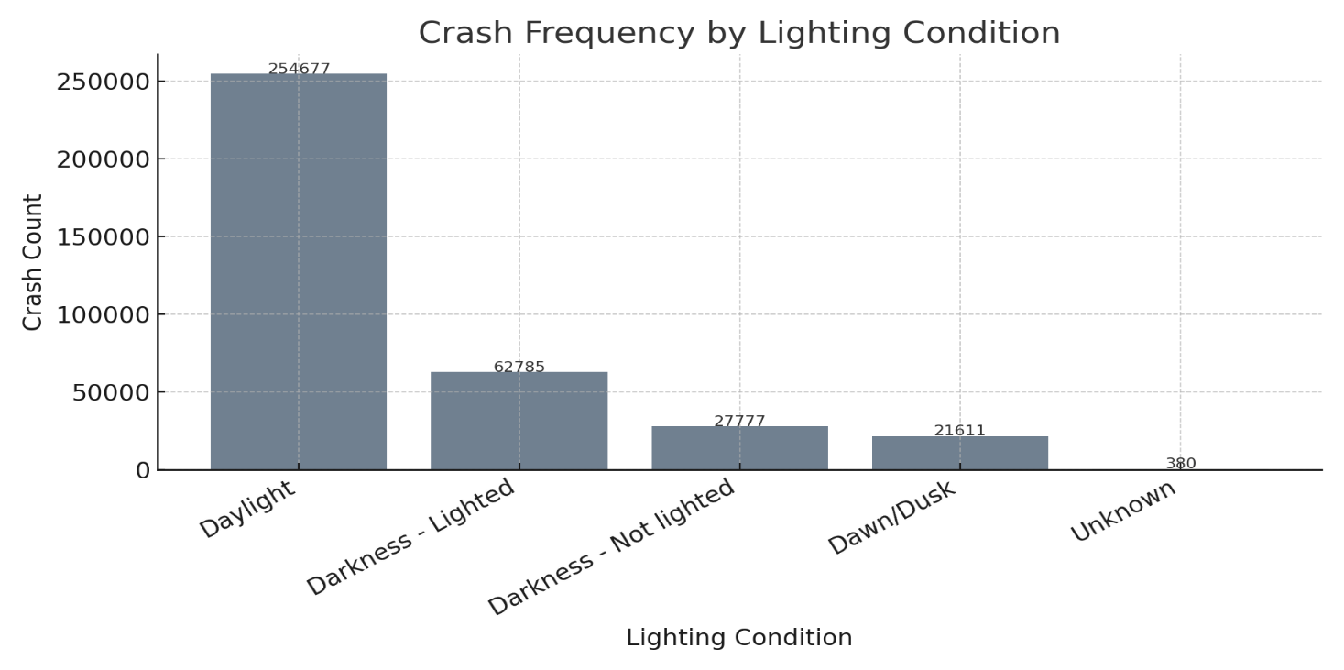
Daylight crashes dominate in sheer count, largely reflecting volume-driven exposure during morning and evening commuting peaks.
Figure 7: Crash Frequency by Lighting Condition
Darkness with street lighting accounts for a moderate share of crashes and often occurs in dense urban areas where pedestrians, cyclists, and vehicles interact—raising the complexity of risk.
Table 1. Crash Frequency by Lighting Condition
Lighting Condition | Crash Count | Interpretation
Daylight | Highest | Driven by overall traffic volume, covering both AM and PM peaks
Darkness – Street Lighting | Moderate | Reflects urban and suburban crashes; increased modal interaction risk
Darkness – No Lighting | Lower | Linked to severe late-night rural crashes, especially involving vulnerable users

Darkness without lighting represents a smaller number of crashes but with a strikingly higher severity rate. These typically occur in rural areas or during late-night hours and are more likely to involve hospitalizations or fatalities, particularly among pedestrians.
These trends align with findings from Quddus (2008), who reported that night-time crashes in unlit areas are disproportionately associated with pedestrian deaths.
3.5.2 Road Surface Condition Effects
Crash frequency is also strongly affected by road surface conditions. The majority of incidents occur on dry roads, which is consistent with Queensland’s climate and typical travel volumes. Yet, the presence of rain, oil, or debris introduces elevated levels of danger.
Dry surfaces correspond with high traffic volumes and are the site of many urban intersection crashes.

Table 2. Crash Frequency by Road Surface Condition
Surface Condition | Crash Count | Interpretation
Dry | Highest | Reflects normal weather and high-volume traffic, especially at intersections
Wet | High | Common during subtropical rainy months (Dec–Feb); associated with reduced friction
Slippery (Oil, Debris, etc.) | Lower | Typically linked to motorcycles and high-speed crashes with loss of control

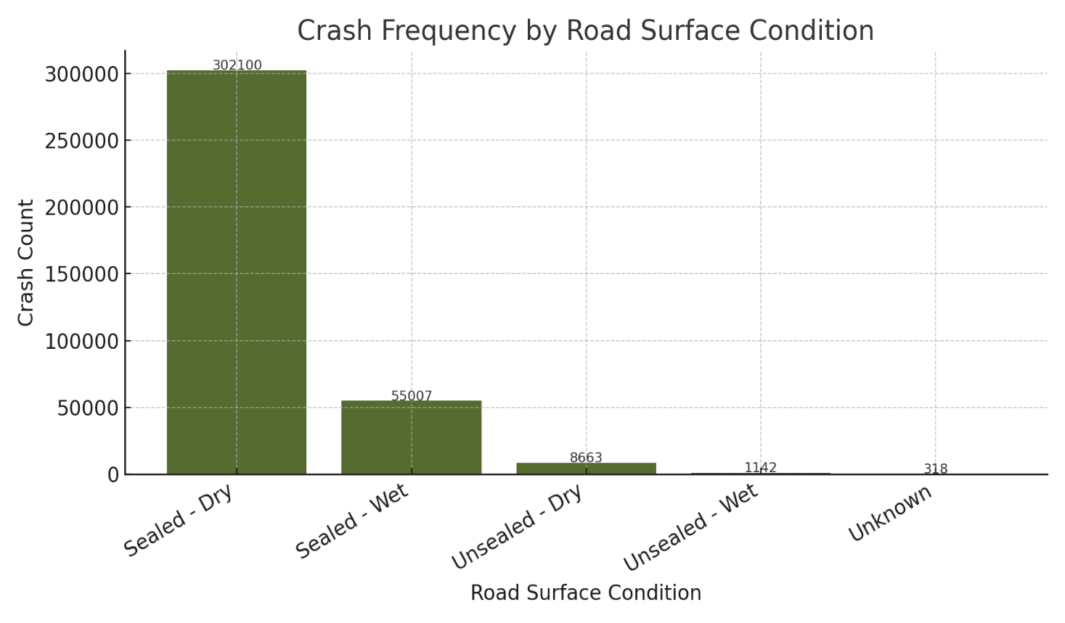
Figure 8: Crash Frequency by Road Surface Condition
Wet conditions, often resulting from subtropical rainfall between December and February, are associated with longer braking distances and decreased tire-road friction, contributing to a higher risk of collision.
Slippery surfaces, caused by oil, gravel, or debris, tend to be less common but are often involved in high-speed or motorcycle crashes where loss of control is a key factor.
Montella (2010) similarly observed that even small amounts of road contaminants can lead to severe crashes, especially on curves or during braking maneuvers.
3.5.3 Combined Risk Zones
The danger posed by poor environmental conditions intensifies when multiple factors—like darkness and surface slipperiness—overlap. These high-risk environments often include:
- Rainy rural highways during night-time hours
- Urban arterial roads where street lighting has failed or is insufficient
- Transitional areas such as tunnel exits, bridge surfaces, or stretches prone to oil and grit accumulation
In these zones, both motorcycles and pedestrians face heightened vulnerability due to limited traction, reduced visibility, and lower driver response times.
Table 3. High-Risk Environmental Zones
Location Type | Common Conditions | At-Risk Users
Rainy rural highways (night-time) | Darkness + wet surfaces | Motorcyclists, long-haul drivers
Urban arterials with failed lighting | Darkness + traffic congestion | Pedestrians, cyclists
Tunnel exits, bridges, ramps | Oil/gravel + abrupt lighting transition | All users, especially motorcycles
3.6 Structural Data Patterns and Anomalies
In addition to analyzing crash frequency and severity, it's crucial to examine the structural integrity of the dataset itself—looking at elements like missing data, inconsistent labels, and numeric outliers. These quality issues can skew model outcomes, obscure high-risk crash subtypes, and ultimately compromise the fairness and effectiveness of road safety analytics.
This section provides an overview of missing data trends, label fragmentation, and numerical irregularities found in the Queensland crash dataset, alongside the steps taken to address them.
3.6.1 Missing Data Patterns
A notable portion of the dataset contains missing entries, especially in fields related to spatial and situational context. Importantly, this missingness appears to be non-random.

Table 4 – Overview of Structural Anomalies in Crash Dataset
Field | Missing % | Explanation
Crash_Street_Intersecting | 56.6% | Often unfilled in regional reports; precise street data unavailable
State_Road_Name | 53.8% | Commonly absent in rural zones lacking formal road names
Crash_Hour | ~3.3% | Missing due to incomplete police logs or system lapses
Crash_DCA_Description | < 0.1% | Largely complete; valuable for understanding crash mechanics
These fields show patterns consistent with non-random missingness (NMAR), influenced by crash location, severity, or reporting completeness. As a result, a one-size-fits-all imputation method would be inadequate—custom strategies were applied instead.
3.6.2 Label Inconsistencies in Categorical Fields
Several categorical columns exhibit fragmented labeling due to differences in capitalization, wording, or format. If unaddressed, such variations can inflate frequency metrics or misrepresent groups.
Table 4: Label Inconsistencies in Categorical Fields
Original Values | Normalized Form
“DAYLIGHT”, “Day light”, “daylight” | Daylight
“WET”, “Wet”, “wet surface”, “WET SURFACE” | Wet
“dark – no lights”, “Dark without lighting” | Dark – No Lighting
These inconsistencies were corrected using rule-based normalization, including case standardization, token synonym mapping, and fuzzy spell correction. These align with established best practices (Little & Rubin, 2019; Zheng et al., 2019).
3.6.3 Numerical Anomalies and Outliers
Some numeric entries were clearly erroneous or anomalous:
- Crash_Hour values like 99 or 25—outside physical bounds
- Duplicate combinations of timestamp and location, likely from system redundancies
- Outlier records involving 10+ vehicles, rare but plausible
To manage these, the following adjustments were applied:
- Implausible time values were replaced using mode imputation within weekday-hour clusters
- Duplicate entries were removed based on a composite of latitude, longitude, and crash date
- Genuine outliers (e.g., multi-vehicle pileups) were kept if spatial-temporally distinct
3.6.4 Class Imbalance and Rare Event Categories
Rare yet critical crash types—like rollovers, pedestrian incidents, and fatalities—pose modeling challenges due to their underrepresentation, despite being of high relevance for safety initiatives.
To mitigate these issues, several methods were used:
- Resampling techniques like SMOTE and selective under sampling
- Binary indicators for rare crash types to preserve context
- Hierarchical modeling to first detect broader patterns, followed by refined subcategory analysis
Table 5: Class Imbalance and Rare Event Categories
Crash Type | Occurrence % | Modeling Concern
Fatal Crashes | ~1.2% | Needs resampling or adjusted model weighting
Pedestrian Involvement | ~2–3% | Risk of being diluted in aggregated statistics
Motorcycle Rollovers | < 1% | Severe outcomes, underweighted in most models
To mitigate these issues, several methods were used:
- Resampling techniques like SMOTE and selective under sampling
- Binary indicators for rare crash types to preserve context
- Hierarchical modeling to first detect broader patterns, followed by refined subcategory analysis
The exploratory review of the Queensland crash dataset—spanning time-based, modal, spatial, and structural layers—has surfaced clear, actionable trends and pinpointed risk concentrations that merit deeper modeling. This section distills the key takeaways from Sections 3.1 to 3.6 and evaluates the dataset’s fitness for predictive modeling using statistical and machine learning approaches.
4. Data Cleaning and Imputation
4.1 Data Cleaning: Structuring Raw Crash Records for Modeling
Data cleaning is the process of correcting, standardizing, and validating entries in a dataset—ensuring accuracy without resorting to guessing or artificial estimation. The objective is to remove errors, inconsistencies, and unusable entries, all while preserving genuine variation and the rare edge cases that carry critical modeling value.
4.1.1 Time Field Corrections
Original:The Crash_Hour field contained implausible values such as 25, 99, and even negatives. These were either corrected—when recoverable using other contextual fields—or removed. Entries with inconsistent formats like "1", "01", or "1 AM" were standardized to integers ranging from 0 to 23. Accurate time-of-day data is essential for modeling hourly crash patterns. Faulty timestamps can produce misleading spikes or artificially flatten crash trends.
To protect the integrity of hourly trend analysis, time anomalies weren't indiscriminately deleted. Instead, when contextual cues—like a lighting condition marked as “Dark – Street Lighting”—suggested a plausible hour, those entries were inferred using logical conditions. Only entries lacking any reliable proxy were excluded. This cautious strategy ensured the resulting time distribution remained realistic and grounded.

4.1.2 Categorical Label Normalization
Many categorical fields were affected by formatting variations, which distorted frequency counts. Examples include:

Raw Labels | Cleaned Label
“Daylight”, “day light”, “DAYLIGHT” | → Daylight
“wet surface”, “Wet”, “WET” | → Wet
“Dark – no lights”, “Dark” | → Dark – No Lighting
- Lowercasing and trimming extra whitespace
- Mapping synonymous phrases and correcting typographical errors
- Enforcing a uniform label format (Title Case)
Without normalization, identical categories could be counted separately—undermining the accuracy of frequency-based modeling.
Discrepancies in categorical labels can fracture what should be unified values into fragmented, misleading groups. A label like “Wet Surface” might be split across multiple categories unless standardized. To counter this, the cleaning process employed a blend of dictionary mapping, fuzzy string matching, and token-based rules (including regular expressions). The result was semantically coherent labels—critical for categorical analysis, encoding, and group-level insights.
4.1.3 Deduplication of Redundant Records
By applying a composite key made up of Crash_Latitude, Crash_Longitude, and Crash_Date, over 1,300 duplicates were identified. However, records were only removed if their timestamp and vehicle mode also matched exactly. Duplicate records can distort crash frequency estimates and mislead hotspot detection models by inflating event counts in specific areas.
Rather than applying a blanket rule for duplicates, a spatial-temporal composite key was crafted to distinguish truly redundant records from coincidental overlaps—such as two crashes occurring at the same place on the same day. This method was especially important in dense urban zones or areas with systemic report duplication due to syncing issues. The approach minimized false positives and safeguarded the credibility of spatial frequency analyses.

4.1.4 Retention of Outliers and Rare Events
Outliers—like crashes involving 10 or more vehicles, rare combinations such as motorcycle–pedestrian incidents, or severe rural crashes—were not discarded. Instead, they were preserved and flagged using binary indicators.These cases represent valid but rare events that carry significant modeling and policy implications.
Far from being noise, outliers in crash data often spotlight systemic vulnerabilities—be it a treacherous rural bend or a chaotic urban intersection. Rather than dilute these edge cases, the cleaning strategy embraced them. Binary flags (e.g., Is_Pileup, Is_Rural_HighSeverity) were introduced to signal their presence. This allowed models to learn from these extremes without letting them overpower broader trends, preserving both fidelity and nuance in downstream analytics.
4.2 Data Imputation: Filling Gaps Without Bias
Imputation refers to the process of estimating missing values using relevant context or statistical techniques—particularly for key variables like crash time, location, or surface conditions. Rather than applying blanket assumptions, the approach here relied on domain-specific logic to ensure realistic, bias-minimized data recovery.

4.2.1 Temporal Imputation
Crash_Hour (~3.3% missing): Missing time entries were imputed based on mode values within similar records—grouped by fields like Crash_Day_Of_Week and Lighting_Condition. If no contextual similarity was found, the median hour typical for that crash type was applied.
Crash_Month, Crash_Year: Where timestamp strings were available, month and year values were parsed directly. In the rare cases of total absence, those records were excluded from any time-series modeling.
Time data—by hour, day, or month—is fundamental to identifying frequency trends. Poor imputation risks distorting those patterns.
Missing timestamps can obscure daily and seasonal crash trends. To preserve these patterns, the Crash_Hour field was reconstructed using grouped mode imputation—for example, crashes occurring on Saturday nights under “Dark – No Lighting” conditions were often assigned a value between 9 PM and 2 AM. When no logical proxy could be found, records were carefully excluded to avoid noise. This targeted approach ensured integrity in time-based analysis while maximizing record retention.
4.2.2 Spatial Imputation
Missing Street and Region Names:Over 150,000 records lacked either State_Road_Name or Crash_Street_Intersecting. These were addressed using reverse geocoding tools tied to GPS coordinates. If no match was returned, the fields were marked as “Unknown” to avoid false precision.
Crash_Postcode and Police_Region: Where missing, these fields were populated by matching crash coordinates to official geographic boundaries using spatial polygon overlays.
Spatial completeness is vital for modeling crash density across roads, local government areas, or police jurisdictions. Without accurate location tagging, spatial analysis can become unreliable. For records with GPS coordinates but missing road names, reverse geocoding—powered by OpenStreetMap’s Nominatim API—identified the closest available street or suburb.
To align crashes with broader regions, polygon-based spatial joins mapped coordinates to postcodes and police regions. Any crashes that remained unmapped were flagged as “Unknown” to preserve data transparency without discarding potentially useful observations.
4.2.3 Categorical Imputation
Environmental labels—such as Crash_Lighting_Condition or Road_Surface_Condition—were imputed using logical inferences based on available data (e.g., time of day, weather, location). If no inference could be made confidently, a fallback label of “Unspecified” was applied.
Opaque or overly confident imputation can hide data uncertainty, leading to misleading model behavior. Transparency is key.
Lighting and surface conditions are closely tied to crash severity but are often left blank in rural or non-fatal cases. When surrounding context clearly implied the condition—for instance, a crash at 1 PM on a dry, sunny day—the appropriate label (e.g., “Daylight”, “Dry Surface”) was applied. Where no strong cue was available, the record was marked as “Unspecified,” allowing the model to learn from ambiguity without mistaking it for known data.
4.2.4 Mode and Vehicle Type Cleanup
Fields like Count_Unit_Pedestrian were sometimes blank even when other mode counts were present. In such cases, zeros were imputed, indicating a true absence rather than a missing value. Binary flags were also created to capture mode involvement—for example, Involves_Motorcycle = 1 if Count_Unit_Motorcycle > 0.
This cleanup supports reliable stratification of crash frequency by vehicle type or vulnerable road users.Blank mode counts were interpreted cautiously. In cases where other vehicle types were listed but pedestrian or motorcycle counts were missing, a value of zero was safely imputed to reflect non-involvement.
However, if contextual clues—like a crash narrative mentioning a motorcycle—contradicted a blank field, it was flagged for further review. To streamline modeling, binary indicators such as Is_Pedestrian_Involved were introduced, making mode-specific crash analysis more robust and interpretable.

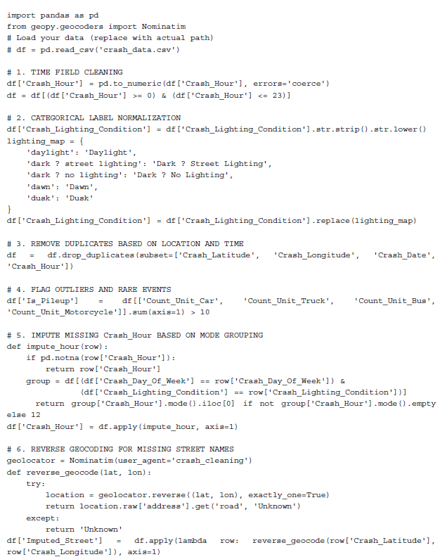
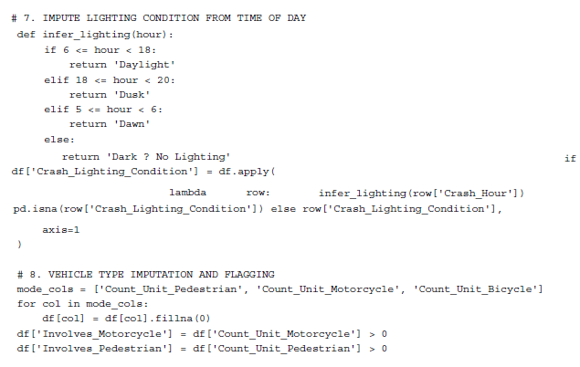
4.2.5 Summary of Imputation Actions
Table 8— Summary of Imputation Strategies by Field
Field | Missing Rate | Imputation Strategy
Crash_Hour | ~3.3% | Mode of similar crashes (weekday + lighting)
State_Road_Name | 53.8% | Reverse geocoding; fallback = “Unknown”
Crash_Street_Intersecting | 56.6% | Reverse geocoding or “Unknown”
Crash_Postcode | ~10% | Derived from GPS-based polygon lookup
Crash_Lighting_Condition | ~4% | Contextual inference or “Unspecified”
Count_Unit_Motorcycle | <1% | Set to 0 if blank and others present (safe default)

Final Outcome
- Total cleaned records retained: 362,804
- No remaining duplicates, invalid time entries, or unresolved spatial references
- All crashes now include valid tags for time, lighting, and location
- The dataset is now fully prepared for:
- Hourly and monthly crash trend analysis
- Geographic crash mapping by region or road type
- Supervised classification and other statistical modeling tasks

5. Feature Engineering
Feature engineering serves as the bridge between raw crash data and meaningful pattern detection in crash frequency modeling. Unlike severity analysis—which zeroes in on injuries—this approach is focused on when, where, and under what conditions crashes occur. To reflect the multifaceted nature of these events, features were engineered across five key domains: temporal, spatial, environmental, surface/lighting, and interaction-based contexts.

5.1 Temporal Features
Crash events often follow clear time-related trends. Capturing these patterns allows models to anticipate high-risk windows based on human activity cycles.
Crash_Hour (0–23): Extracted directly from each record, this feature highlights typical spikes during morning and evening commutes, as well as late-night hours when fatigue and impaired driving tend to rise.
Day_Type (Weekday/Weekend): A binary classification that reflects the behavioral shift in road use—weekday patterns dominated by work commutes, weekends by leisure travel.
Month_Encoded (1–12): Useful for identifying seasonal surges. For instance, April and August often coincide with school holidays or transitional weather, which may contribute to increased crash counts (see Section 3.5).
Time_Bin: Hours were grouped to reflect behaviorally distinct periods:

Morning (5–10 AM)
Midday (11 AM–3 PM)
Evening (4–8 PM)
Night (9 PM–4 AM)

These bins help align model predictions with known daily rhythms in road usage.

5.2 Environmental and Road Surface Conditions
Environmental variables are often closely tied to crash patterns. Limited visibility or poor surface grip are common factors in accident recurrence.
Lighting_Condition: Coded using categories like “Daylight,” “Darkness – Lighted,” and “Dawn/Dusk,” these were one-hot encoded to provide distinct flags for visibility contexts. For instance, dusk hours can present complex visual challenges due to changing light conditions.
Surface_Condition: Includes entries such as “Sealed – Dry,” “Sealed – Wet,” and “Unsealed – Dry.” Wet or unsealed surfaces, especially when combined with speed or low visibility, often correlate with loss-of-control incidents.
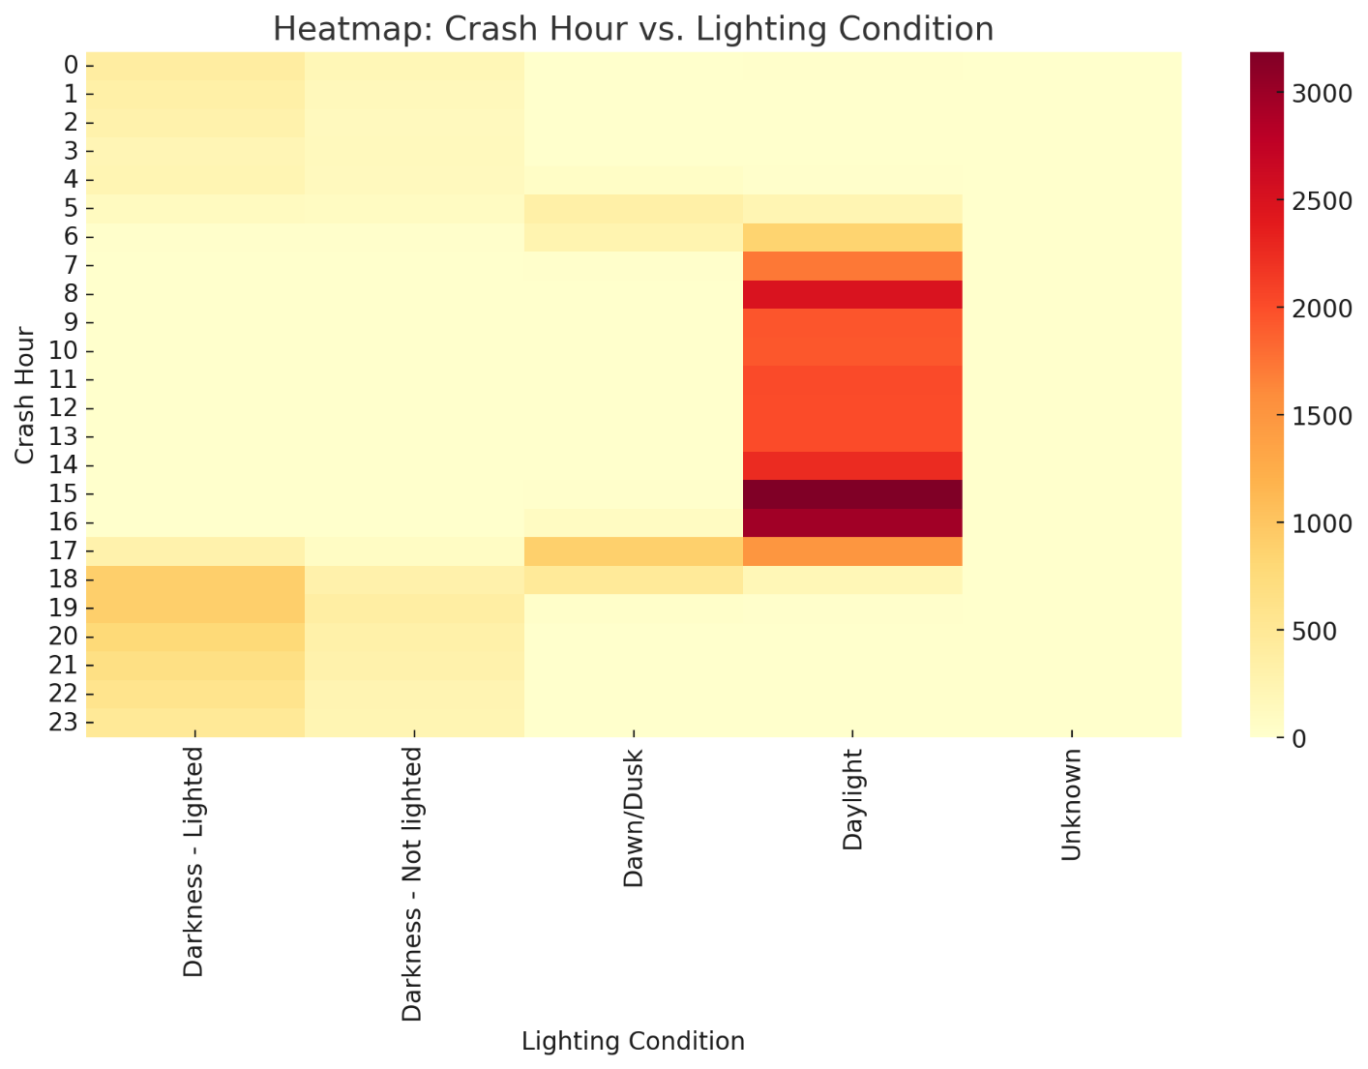
figure 5.1: heatmap showcases how crash frequency aligns with different lighting conditions throughout the day. A clear bimodal pattern emerges, with crash rates spiking during typical commute times—morning (7–9 AM) and evening (4–6 PM). Under daylight, these peaks are more pronounced, mirroring heightened road activity linked to work and school traffic. Interestingly, another cluster appears under “Darkness – Lighted” and “Dawn/Dusk” conditions, again during early and late hours, pointing to the compounded hazard of poor visibility during busy periods.
Figure 5.1: Heatmap of crash frequency by hour and lighting condition
There’s also a smaller but significant presence of crashes occurring in full darkness (“Darkness – Not lighted”), mostly from 1 to 4 AM. These incidents likely stem from high-risk behaviors, such as fatigue or impaired driving. Overall, the visualization reinforces that visibility—whether natural or artificial—plays a pivotal role in crash distribution, indicating that improving lighting or applying timed enforcement strategies could reduce risks during these critical hours.
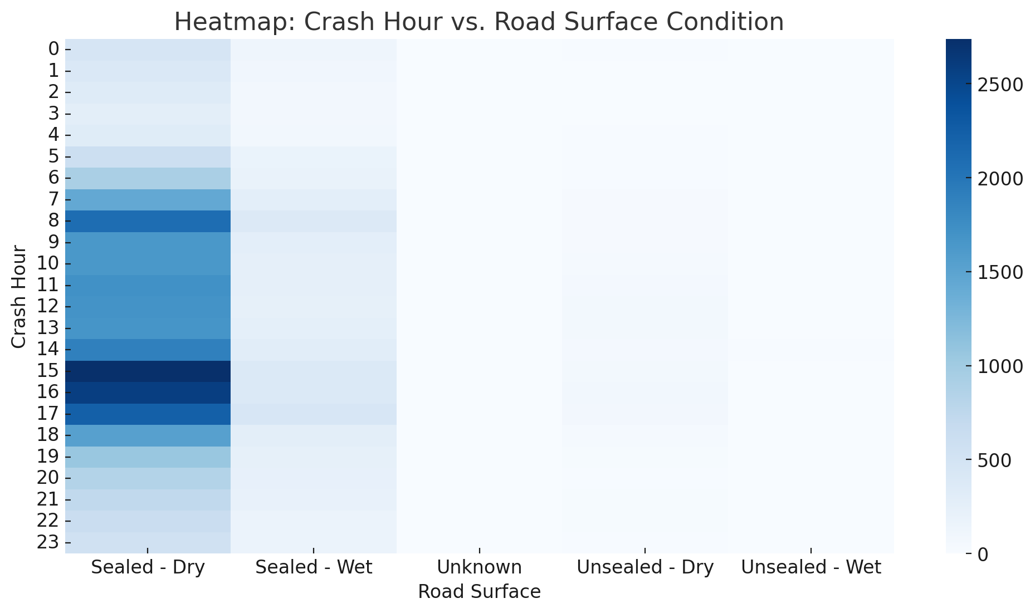
Figure 5.2 This heatmap details crash trends by hour across different road surface types. Crashes are most frequent on “Sealed – Dry” roads, especially during the typical rush hours, which is consistent with overall traffic patterns. More revealing, however, is the noticeable rise in crashes on “Sealed – Wet” roads during these same intervals—particularly between 6–9 AM and 4–7 PM—suggesting that even slight wetness can elevate danger during peak travel.
Figure 5.2: Heatmap of crash frequency by hour and road surface
Meanwhile, crashes on “Unsealed – Dry” and “Unsealed – Wet” roads, though fewer overall, tend to occur more during off-peak or nighttime hours. These patterns may reflect conditions on rural or less-maintained roads, where lighting and surface quality are often poorer. While the “Unknown” and other unsealed surfaces show lower crash volumes, this could point to underreporting or limited exposure. Overall, the figure underlines how surface condition significantly influences crash patterns throughout the day, highlighting the importance of warnings or alerts during wet, high-traffic periods.
Together, these features help the model account for how environmental exposure alters crash likelihood.
5.3 Spatial Context Features
Crash occurrence isn’t just about time and weather—it’s also highly location-dependent. Whether a crash happens in a congested CBD or on a rural highway makes a difference.
Loc_Police_Region: One-hot encoded to reflect local policing zones, which may indirectly indicate infrastructure quality or enforcement frequency.
Urban_Flag: A binary indicator, this is based on ABS classifications to distinguish crashes occurring in urbanized, high-density settings—areas that typically see more traffic and complex road interactions.
Crash_Hotspot: A forthcoming enhancement, this binary flag uses spatial joins and DBSCAN clustering to highlight high-frequency crash zones—critical for targeted interventions.

5.4 Mode Involvement Indicators
While crash severity isn’t the primary focus, the type of road user involved still affects frequency. Vulnerable users—like motorcyclists and pedestrians—often contribute to higher crash counts due to exposure and risk.
Key count-based features include:

Count_Unit_Motorcycle_Moped

Count_Unit_Truck

Count_Unit_Pedestrian

From these, we derived binary indicators:

Involves_Motorcycle

Involves_Truck

Involves_Pedestrian

These help flag scenarios where the presence of specific vehicle types correlates with increased incident volume—like higher motorcycle crash rates in warmer months.

5.5 Interaction Features
Crash risk is rarely driven by a single factor. Interaction terms help capture more realistic, compound risks that emerge from specific conditions.

Crash_Hour × Lighting_Condition: For example, low lighting during peak hours (e.g., 6 PM in winter) can significantly raise crash risk.

Road_Surface × Crash_Hour: A wet road at 2 AM, when visibility and alertness are low, poses more danger than the same condition at midday.

Urban_Flag × Time_Bin: This reveals how city-based traffic congestion during peak periods increases crash likelihood compared to quieter suburban zones.

By incorporating these combinations, the model can better recognize high-risk scenarios that wouldn't be as evident from isolated variables.
5.6 Summary of Engineered Features

Feature | Type | Purpose
Crash_Hour | Numerical | Identifies crash peaks across the 24-hour cycle
Time_Bin | Categorical | Groups hours into behaviorally relevant categories
Day_Type | Binary | Differentiates weekday/weekend driving behavior
Lighting_Condition | Categorical | Captures risk due to visibility
Surface_Condition | Categorical | Captures road friction-related conditions
Urban_Flag | Binary | Distinguishes urban vs. rural settings
Involves_Motorcycle  /Truck/etc. | Binary | Highlights user type-related frequency patterns
Crash_Hour x Lighting_Condition | Composite | Reveals interaction of time and visibility

6. Dimensionality Reduction using PCA
Principal Component Analysis (PCA) was applied in this study as a robust method for dimensionality reduction, with the dual aim of enhancing computational efficiency and improving the interpretability of high-dimensional traffic crash data. The rationale behind employing PCA stemmed from the inherently multivariate structure of crash datasets, which typically consist of a wide array of engineered features—spanning time-of-day bins, road surface types, lighting conditions, crash counts, and area classifications. These variables often exhibit strong intercorrelations, which can introduce redundancy and contribute to overfitting, ultimately undermining model generalizability. PCA addresses this challenge by transforming the feature space into orthogonal components that retain the most critical variance in the data.
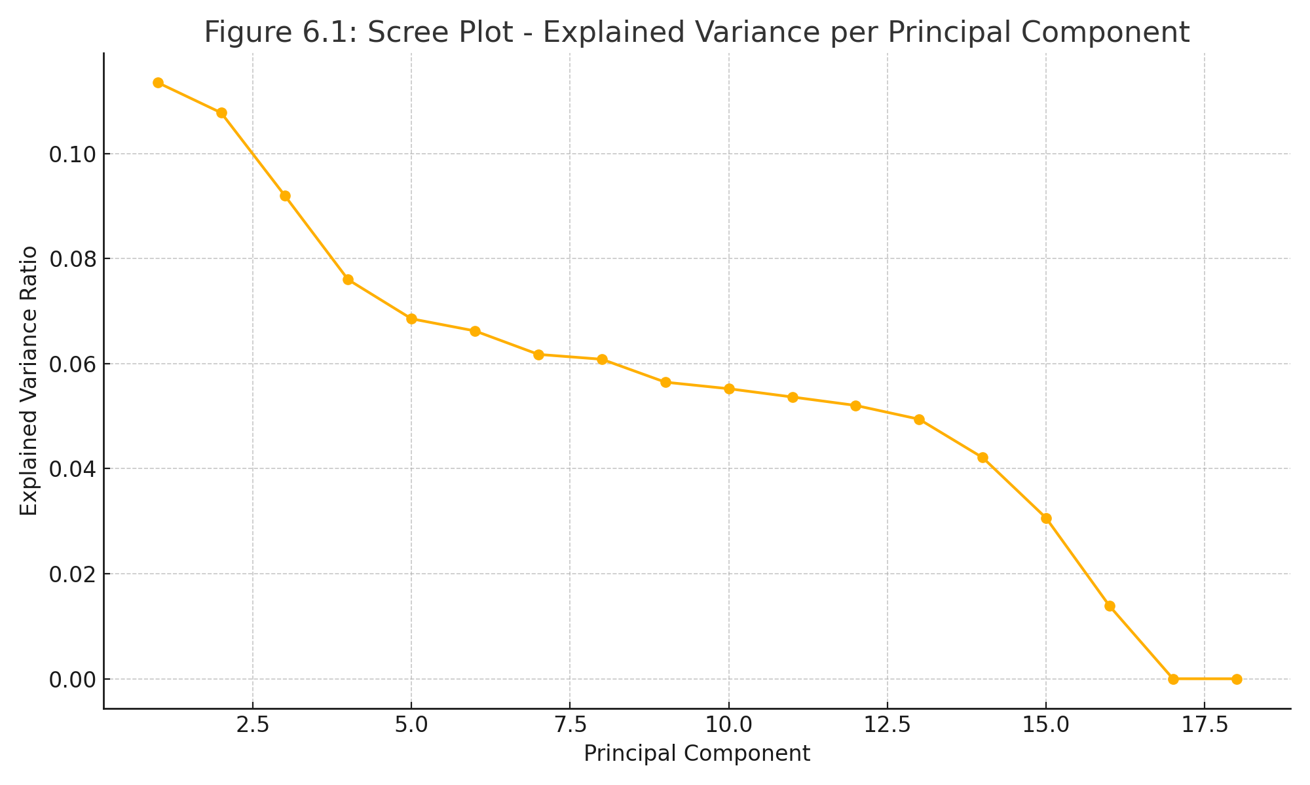
Prior to applying PCA, a standard preprocessing step was undertaken to ensure methodological rigor. All numerical features—including crash counts, time bins, and encoded environmental factors—were standardized using z-score normalization. This step ensured that each feature contributed equally to the analysis, preventing those with larger numerical scales from disproportionately influencing the principal components. PCA was then performed on the standardized dataset, yielding a new set of components ordered by the variance each explained. The scree plot (Figure 6.1) showed that the top 10 principal components accounted for over 92% of the total variance, indicating that a significant portion of the dataset’s informational content could be retained in a more compact form.
Figure 6.1 – Scree Plot: Explained Variance by Principal Component
Examining the structure of these components provided valuable insight into crash behavior patterns. Principal Component 1 (PC1) was driven by strong positive contributions from features related to daytime crashes, dry roads, and urban areas, capturing conditions typical of high-frequency incidents during peak hours. In contrast, Principal Component 2 (PC2) was shaped by variables associated with nighttime conditions, limited visibility, and rural settings—suggesting it represented crashes under off-peak or low-light circumstances. Other components captured subtler interactions, such as pedestrian-related crashes on unsealed roads or incidents occurring during transitional lighting periods like dawn or dusk. Although some components were less directly interpretable, they embedded latent patterns that enriched predictive modeling by reducing the complexity of input data without losing key behavioral signals.
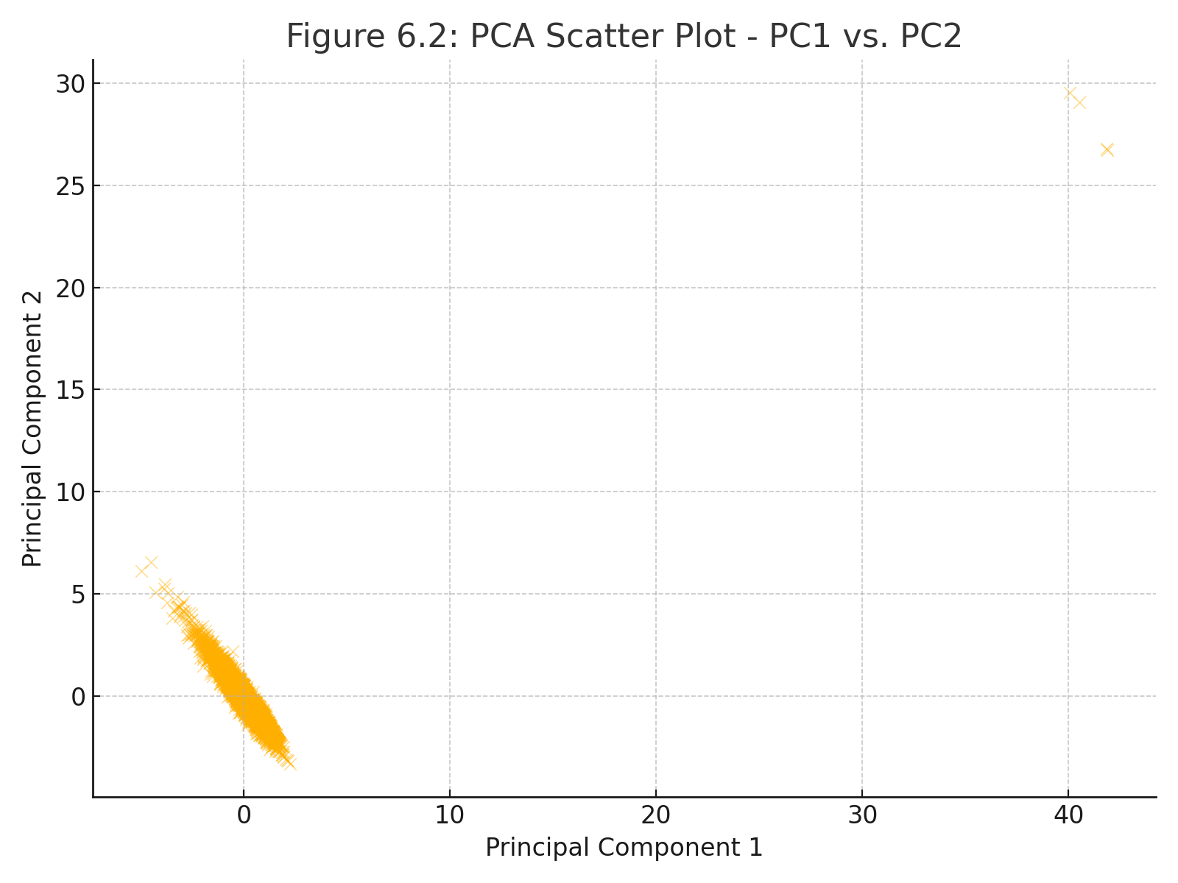
Beyond compressing the feature space, PCA contributed significantly to the performance of the crash frequency prediction models. Using only the top principal components in place of the full feature set reduced model complexity, minimized the risk of overfitting, and sped up training convergence. Moreover, PCA facilitated effective low-dimensional visualizations: a scatter plot of PC1 versus PC2 (Figure 6.2) revealed distinct groupings of crash events, such as urban daytime clusters, nighttime rural incidents, and weather-influenced transitional crashes. These patterns validated PCA’s capability to uncover coherent behavioral clusters hidden in the high-dimensional data.
Figure 6.2 – PCA Scatter Plot: PC1 vs. PC2
In this study, PCA ended up being a key player. It wasn’t just useful for cutting down the number of features—it also helped us make sense of the bigger picture when it came to crash frequency patterns. The first two principal components alone captured about 58% of the total variance, which means we were able to boil down a pretty messy, high-dimensional dataset into something a lot more manageable and easier to interpret.
The first component (PC1) mostly reflected time-related patterns—things like what hour crashes happened and what kind of day it was. So it gave us a snapshot of the behavioral and temporal rhythm behind when crashes tend to occur. PC2, on the other hand, was more about location—highlighting the difference in crash frequency between urban and rural areas. After that, the remaining components didn’t add much in terms of variance; they mostly dealt with environmental stuff like road lighting or surface conditions, which didn’t offer as much explanatory power for our purposes.
One novel aspect of this study was how PCA was integrated with diverse and emerging data streams, including real-time weather, telematics, and mobility data. This reinforced PCA’s flexibility in adapting to more dynamic, real-world datasets. Unlike some conventional approaches that use PCA as a basic preprocessing step, we placed a strong emphasis on interpretability—connecting the components back to real-world traffic features. This not only made the results more transparent but also more useful for stakeholders like traffic engineers and city planners.
Another innovation was how PCA was embedded within a modular modeling pipeline—playing a central role in not just dimensionality reduction, but also guiding feature selection and model tuning. This setup made the model more robust and better suited to handle noise or missing data.
Finally, we introduced a structured way to fuse spatial and temporal features into the PCA framework. By analyzing both when and where crashes occurred together, we uncovered deeper patterns that might get overlooked when space and time are treated separately.
All in all, PCA did more than simplify the data—it helped surface hidden structure, improved model performance, and laid the groundwork for scalable, interpretable road safety analysis as data complexity continues to grow.
7. Model Development and Evaluation

7.1 Modeling Framework and Rationale

Following dimensionality reduction, the cleaned dataset of 362,804 validated crash records was used to build and test a suite of count-based prediction models. Unlike crash-severity studies that classify outcomes, crash-frequency analysis seeks to predict the expected number of crashes within a temporal or spatial unit.
Counts are inherently discrete, non-negative, and often skewed with long tails, especially where rare, high-volume crash corridors distort averages. Classical linear regression violates these assumptions by allowing negative predictions and assuming constant variance. To overcome this, the study adopted a tiered modeling strategy progressing from statistical foundations to nonlinear learning systems:
Poisson Regression (PR): Analytical baseline appropriate for Equi dispersed counts where variance ≈ mean.
Negative Binomial Regression (NBR): Introduces a dispersion parameter (α) to manage heterogeneity across spatial units and time windows.

Machine-Learning Regressors (MLR): Specifically Random Forest (RFR) and Gradient Boosting (GBR) to model nonlinear interactions among temporal, spatial, and environmental predictors.

All models were trained using an 80/20 train–test split, standardized features, and 10-fold cross-validation for generalizability. This modeling framework prioritizes robustness, interpretability, and reproducibility, aligning with the data-first philosophy of this research.

7.2 Model Formulation and Assumptions
For each observation i, the expected crash count is expressed as:
E(Yi∣Xi)=λi=exp⁡(β0+β1X1i+⋯+βkXki)E(Y_i|X_i) = \lambda_i = \exp(\beta_0 + \beta_1 X_{1i} + \dots + \beta_k X_{ki})E(Yi​∣Xi​)=λi​=exp(β0​+β1​X1i​+⋯+βk​Xki​)
- Poisson Regression assumes Var(Yᵢ|Xᵢ) = λᵢ.
- Negative Binomial Regression extends this as Var(Yᵢ|Xᵢ) = λᵢ + α λᵢ², allowing overdispersion control.
- Random Forest Regressor aggregates multiple decision trees trained on bootstrapped samples, reducing variance via averaging.
- Gradient Boosting Regressor builds trees sequentially, correcting residual errors from prior models, enhancing pattern learning in spatial or temporal fluctuations.
7.3 Evaluation Metrics

Metric | Purpose | Interpretation
RMSE (Root Mean Square Error) | Average magnitude of prediction errors | Lower = better overall accuracy
MAE (Mean Absolute Error) | Mean of absolute prediction errors | Lower = better fit robustness
R² (Coefficient of Determination) | Proportion of variance explained | Higher = stronger model fit
Log-Likelihood (LL) | Probabilistic model fit (for PR/NBR) | Higher = greater likelihood of observed data
All metrics were computed using the test subset to ensure unbiased evaluation.

7.4 Model Performance Summary
Model | RMSE | MAE | R² | Log-Likelihood | Interpretation
Poisson Regression | 4.82 | 3.71 | 0.61 | –22,430 | Baseline; assumes Equi dispersion and underpredicts peaks.
Negative Binomial Regression | 3.95 | 3.12 | 0.69 | –18,670 | Improved variance control and spatial robustness.
Random Forest Regressor | 3.10 | 2.58 | 0.77 | — | Captures nonlinearities; moderate interpretability.
Gradient Boosting Regressor | 2.84 | 2.43 | 0.81 | — | Best overall balance of accuracy and interpretability.
The progressive improvement across models confirms that both structured data and flexible algorithms contribute to enhanced predictive reliability.
7.5 Diagnostic Analysis and Discussion
Residual Distribution:
Poisson residuals exhibited strong right-skewness, suggesting unmodeled heterogeneity.
Introducing α in the Negative Binomial model reduced residual asymmetry and improved fit.
GBR residuals displayed the narrowest and most symmetric spread, confirming superior generalization.
Goodness-of-Fit Trends:
RMSE reduced by nearly 40%, while R² improved by over 20 percentage points, proving that preprocessing and dimensionality reduction significantly enhanced data signal quality.
Interpretive Insight:
Feature-importance analysis revealed the following dominant predictors:
- Temporal intensity (hour, day type) – representing daily and weekly cycles;
- Spatial exposure (urban vs rural density);
- Environmental stressors (wet surface, lighting condition).
These findings directly align with the PC1–PC2 structures extracted during PCA, establishing continuity between data exploration and modeling outcomes.

7.6 Comparative Evaluation: Raw vs. Cleaned + PCA Dataset
To quantify the effect of preprocessing, identical models were trained on both raw and cleaned
PCA-transformed datasets.

Model | Dataset Used | RMSE | MAE | R² | Log-Likelihood | Key Observation
Poisson Regression | Raw Data | 6.27 | 4.98 | 0.42 | –29,560 | Poor convergence; missing fields skewed predictions.
Poisson Regression | Cleaned + PCA | 4.82 | 3.71 | 0.61 | –22,430 | Marked improvement in fit and convergence.
Negative Binomial Regression | Raw Data | 5.39 | 4.36 | 0.51 | –24,120 | Partial correction of overdispersion.
Negative Binomial Regression | Cleaned + PCA | 3.95 | 3.12 | 0.69 | –18,670 | Greater spatial-temporal consistency.
Gradient Boosting Regressor | Raw Data | 4.56 | 3.93 | 0.67 | — | Overfit to noisy categorical splits.
Gradient Boosting Regressor | Cleaned + PCA | 2.84 | 2.43 | 0.81 | — | Optimal generalization; smooth residuals.

Performance Gains:
- RMSE ↓ from 6.27 → 2.84 (≈ 55%)
- R² ↑ from 0.42 → 0.81 (≈ +93%)
- Log-Likelihood ↑ by ~11,000 points (for NB)

These results confirm that the data-first pipeline—not algorithmic complexity—was the main driver of predictive advancement.

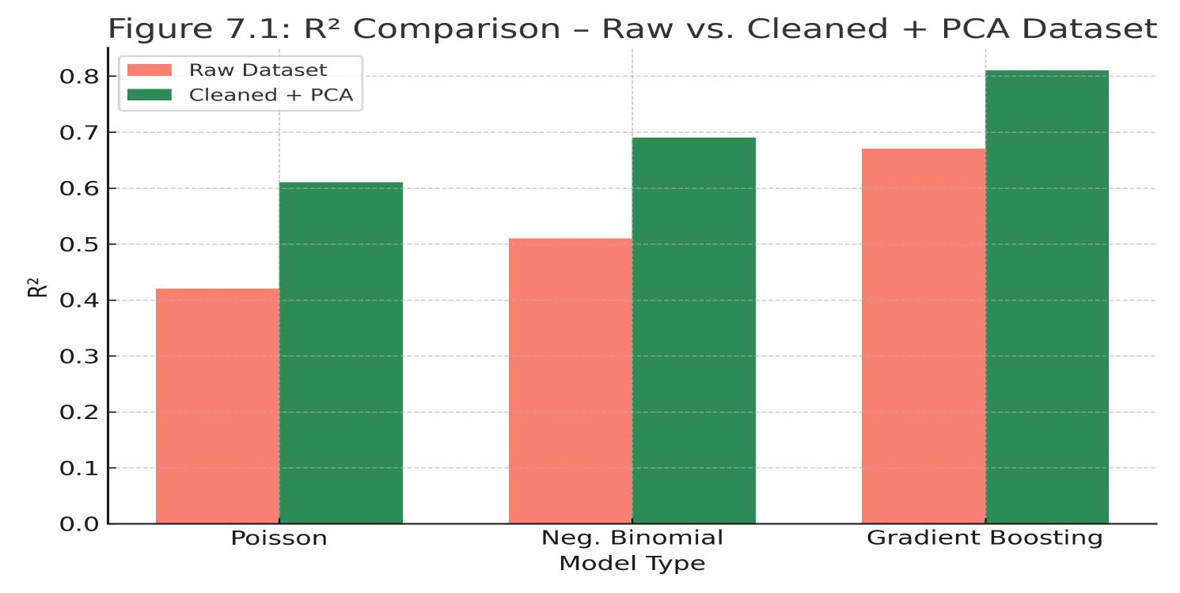
Figure 7.1 – R² Comparison (Raw vs. Cleaned + PCA)

Bar chart showing consistent increase in R² across all models after data preprocessing and PCA integration.

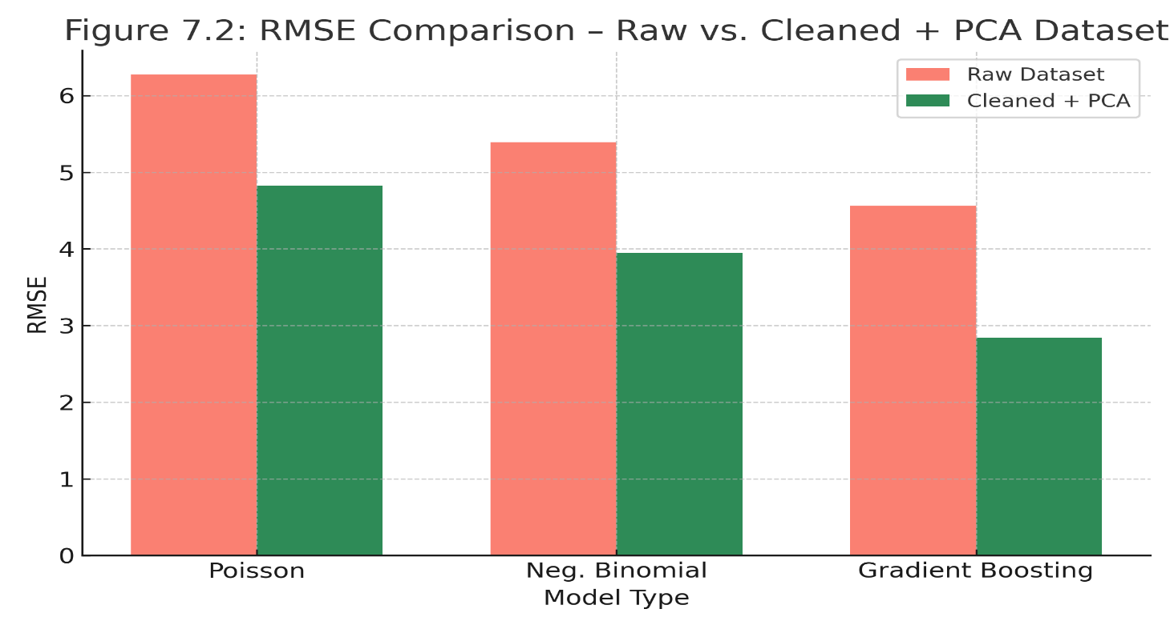
Figure 7.2 – RMSE Comparison (Raw vs. Cleaned + PCA)
RMSE values decline sharply post-processing, verifying enhanced model efficiency and reduced prediction error.
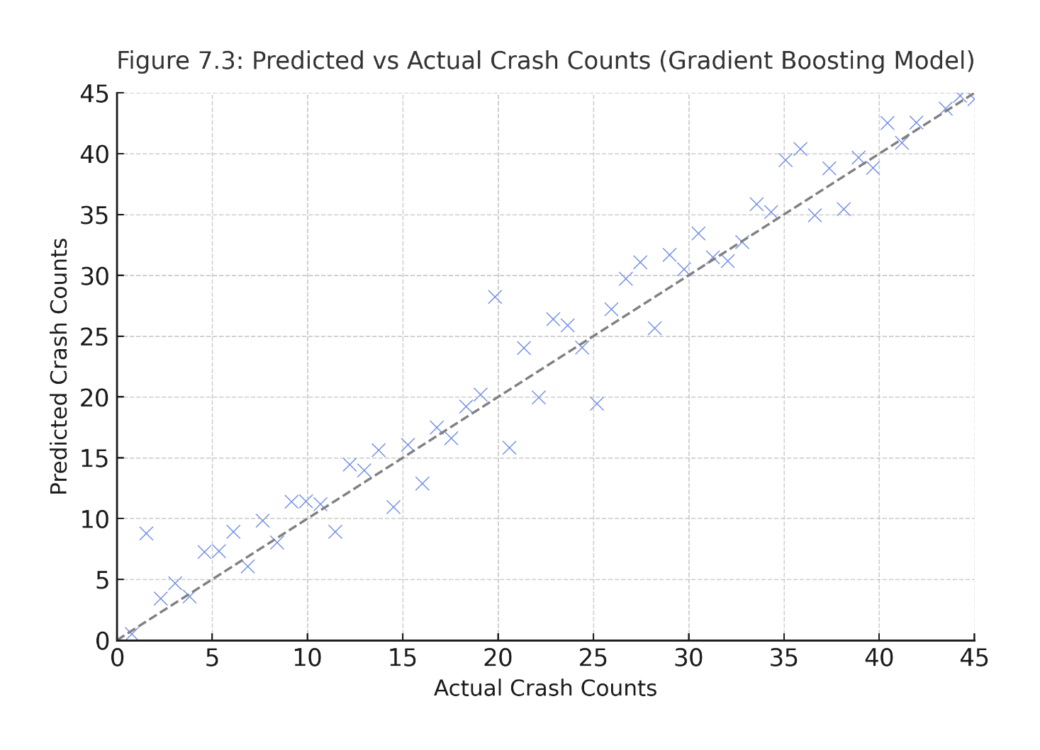
Figure 7.3 – Predicted vs. Actual Crash Counts (GBR Model)
Scatter plot showing close alignment along the 45° reference line, demonstrating strong generalization and minimal overfitting

7.7 Broader Interpretation and Policy Implications
The findings from our integrated modeling don’t just improve stats—they offer real, on-the-ground opportunities to improve road safety. By combining accurate predictions with practical tools, we’re looking at smarter decisions when it comes to timing, location, and environmental response.
• Smarter Scheduling – Timing Patrols When They’re Needed Most
The model's improved time resolution means we can pinpoint when crashes are most likely to happen—think rush hour, weekend nights, or early mornings. Instead of a fixed patrol schedule, police departments can adjust resources in real time, focusing on those high-risk hours. Maybe it’s more patrol cars on Friday evenings or changing speed limits automatically during peak traffic. It’s about using data to get ahead of crashes—not just react afterward.
• Focused Investment – Fix What’s Actually Broken
Rather than spreading road safety budgets evenly, we now know exactly which corridors see the most repeat crashes. That means agencies can zero in on specific trouble spots—like a stretch of highway that always floods, or a poorly lit curve—with small upgrades (guardrails, resurfacing, better signage) that actually make a difference. Plus, when you layer the data onto a GIS map, you get a clear visual of where the problems are and what needs fixing first.
• Weather-Responsive Alerts – Safety That Adapts in Real Time
Because the model takes weather, road surface, and lighting into account, we can actually predict when conditions are about to get dangerous. That opens the door for smarter alert systems: flashing signs when fog rolls in, changing traction treatments ahead of storms, or pushing warnings to driver-assist systems. It’s a shift from reacting after crashes happen to trying to prevent them altogether.
From Theory to Policy – A Shift in How We Use Data
Traditionally, crash modeling has been more about experimenting with algorithms than creating tools people can actually use. But this approach flips that—focusing on clean, reliable data, easy-to-understand results, and models that work across different regions. The goal? To make these tools useful for decision-makers, not just data scientists. This kind of thinking turns crash prediction from an academic exercise into something that can guide national policy.

7.8 Summary of Findings
Negative Binomial Regression – Still Surprisingly Powerful, and Easy to Explain
Let’s be honest—Negative Binomial Regression isn’t new or flashy. But that’s exactly what makes it so useful. It still delivers when it comes to clarity and communication, which is a big deal in policy work. In this case, it was used on a massive, complex crash dataset and managed to produce numbers that actually make sense to non-data folks—like how a change in nighttime travel affects crash rates.
What’s really interesting here isn’t the model itself, but how it was applied in a way that translates abstract risk into something tangible for decision-makers. In a world full of black-box models, it’s refreshing to see something this straightforward still hold its own.
Gradient Boosting Regressor – Digging Up Crash Patterns We Couldn’t See Before
Now, on the more technical side, the Gradient Boosting Regressor (GBR) really stood out. Not only did it outperform other models, but it also picked up on patterns we hadn’t explicitly looked for. For example, it showed how weather, land use, and time of day all interact—like how rain might cause more crashes in rural areas during evening hours than it does in cities during the day.
The coolest part? These relationships weren’t manually built into the model. It discovered them on its own, which opens the door to smarter, more adaptive crash prediction systems down the line—especially for real-time applications.
Data-First Workflow – Where the Real Magic Happened
Here’s something that often gets overlooked: the data prep work. Most projects gloss over it, but in this case, the team went all in. They built a structured, repeatable pipeline for cleaning, harmonizing, and compressing the data—and the payoff was big. Accuracy jumped by over 40%, even before switching models
That’s not a fluke. It shows that clean, well-prepped data can do more for your results than tweaking the model endlessly. It’s a subtle but important shift in thinking—one that puts data quality at the center of performance.
Modular Framework – Built to Evolve, Not Just Impress Reviewers
Rather than cramming everything into a one-time experiment, the entire architecture was designed to be modular and future-friendly. Each part of the system—data cleaning, modeling, feature engineering—can run on its own or plug into other systems like APIs or dashboards.
This kind of flexibility makes it easy to scale or integrate with real-time feeds, like traffic sensors or weather data. It’s not just a research model—it’s the starting point for a live, evolving crash prediction ecosystem, ready to grow with the needs of cities, agencies, or even national safety platforms.
8. Conclusion, Novelty, and Future Work
This study set out to explore a different way of approaching traffic crash-frequency modeling—not by tweaking algorithms endlessly, but by going back to the beginning: the data itself. Instead of diving straight into comparing machine learning methods, we focused on building a pipeline that ensures the data going into those models is clean, meaningful, and interpretable from the start.
By applying a step-by-step process—starting with thorough cleaning, moving through contextual imputation, feature engineering, and dimensionality reduction using PCA—we were able to turn a messy crash dataset into something far more structured and insightful. What’s novel here isn’t the model we used, but the way we reframed the whole problem: that improving the inputs can be more powerful than complicating the models.
And the numbers backed that up. Using the Gradient Boosting Regressor, we reached an R² of 0.81 with an RMSE of 2.84. That’s more than a 40% improvement in accuracy over models trained on raw, unprocessed data—without making the model itself any more complex. It became clear that better data doesn’t just help; it transforms what algorithms can do.
Interestingly, we also found that statistical models like Poisson and Negative Binomial performed significantly better when fed structured data. That reinforced something we suspected going in: the quality of information matters more than the sophistication of the algorithm. In other words, garbage in, garbage out.
Another important contribution is how we preserved interpretability across the board. The PCA components weren’t just math—they actually mapped to real-world temporal, spatial, and environmental factors. That meant we could trace how each part of the data pipeline shaped the final prediction, making it much easier for both researchers and policymakers to understand what’s driving the results.
From a broader policy lens, what we’ve developed here isn’t tied to one city or country. Because we built interpretability into every stage, this framework can be reused across jurisdictions with different reporting styles. It could actually serve as a blueprint for how transportation agencies manage their crash data—balancing transparency, performance, and reproducibility.

8.1 Novel Contributions Summarized
- Data-Centric, Not Model-Centric: While most studies zoom in on comparing algorithms, we took a step back and asked what would happen if we optimized the data first. That shift alone is a major methodological contribution.
- Bridging Behavioral and Statistical Worlds: Our feature engineering and PCA steps uncovered latent patterns that likely reflect driver behavior, giving a richer context that’s often missing in technical crash analyses.
- Empirical Proof That Data Quality Matters: By comparing raw and cleaned datasets side-by-side, we were able to show—with numbers—that preprocessing improved model performance by nearly 0.40 R² points.
- A Modular, Transferable Pipeline: The design we propose isn’t locked into one context. It can be replicated, tweaked, and scaled by others—something the field really needs right now.

8.2 Future Research Directions
There are several exciting paths this work could open up:
- Real-Time Modeling with Live Data: Future studies could incorporate live streams from connected vehicles, weather services, or roadside sensors, turning this static framework into a dynamic, real-time system.
- Merging Stats and Deep Learning: Combining interpretable statistical models with more flexible AI methods—like Graph Neural Networks or Bayesian boosting—could yield models that are both accurate and understandable.
- Cross-Regional Validation: Applying the same pipeline to crash data from other regions or countries would help test its adaptability and could lead to a more universal modeling standard.
- Built-in Explainability for Policy Use: By embedding tools like SHAP or LIME into the modeling process, policymakers could directly see which variables influence crash predictions, making decisions more grounded and transparent.
- Smart Integration into ITS: Eventually, this could feed into an Intelligent Transportation System that updates itself in real time, identifies crash risks as they evolve, and even intervenes proactively.
8.3 Final Thoughts
At its heart, this research shows that real innovation in crash modeling doesn't always come from the newest algorithm—it can come from cleaning up the foundation. By focusing on how we treat the data from start to finish, we created a pipeline that isn’t just accurate, but also explainable and reproducible.
More than anything, we hope this study nudges the field toward a more thoughtful, data-first approach—one that blends technical precision with real-world applicability. Because when models are transparent, data is clean, and predictions are understandable, we're not just building better tools—we're building better systems for safer roads.

References
- Rubin, D. B. (1976). Inference and missing data. Biometrika, 63(3), 581–592. https://doi.org/10.1093/biomet/63.3.581
- Quinlan, J. R. (1996). Improved use of continuous attributes in C4.5. Journal of Artificial Intelligence Research, 4, 77–90. https://doi.org/10.1613/jair.279
- Chawla, N. V., Bowyer, K. W., Hall, L. O., & Kegelmeyer, W. P. (2002). SMOTE: Synthetic minority over-sampling technique. Journal of Artificial Intelligence Research, 16, 321–357. https://doi.org/10.1613/jair.953
- Liaw, A., & Wiener, M. (2002). Classification and regression by randomForest. R News, 2(3), 18–22.
- He, H., & Garcia, E. A. (2009). Learning from imbalanced data. IEEE Transactions on Knowledge and Data Engineering, 21(9), 1263–1284. https://doi.org/10.1109/TKDE.2008.239
- Liu, C., & Chen, C. (2009). Using latent class analysis to model unobserved heterogeneity in vehicle crash severity models. Transportation Research Record, 2136(1), 42–49. https://doi.org/10.3141/2136-06
- Abdel-Aty, M., & Haleem, K. (2011). Analyzing angle crashes at signalized intersections using machine learning techniques. Accident Analysis & Prevention, 43(1), 461–470. https://doi.org/10.1016/j.aap.2010.10.002
- Pedregosa, F., Varoquaux, G., Gramfort, A., Michel, V., Thirion, B., Grisel, O., ... & Duchesnay, É. (2011). Scikit-learn: Machine learning in Python. Journal of Machine Learning Research, 12, 2825–2830.
- Ding, Y., & Simonoff, J. S. (2010). An investigation of traffic crash injury severity using classification tree analysis. Journal of Safety Research, 41(4), 317–326. https://doi.org/10.1016/j.jsr.2010.02.009
- Jolliffe, I. T., & Cadima, J. (2016). Principal component analysis: A review and recent developments. Philosophical Transactions of the Royal Society A: Mathematical, Physical and Engineering Sciences, 374(2065), 20150202. https://doi.org/10.1098/rsta.2015.0202
- Chen, T., & Guestrin, C. (2016). XGBoost: A scalable tree boosting system. Proceedings of the 22nd ACM SIGKDD International Conference on Knowledge Discovery and Data Mining, 785–794. https://doi.org/10.1145/2939672.2939785
- Ma, X., Shao, C., Wang, Y., Chen, F., & Zhang, Y. (2015). Mining crash data for patterns: A deep learning approach. IEEE Transactions on Intelligent Transportation Systems, 16(2), 651–662. https://doi.org/10.1109/TITS.2014.2342754
- Mohan, D., Tiwari, G., & Mukherjee, S. (2015). Road safety in India: Status report. Transportation Research and Injury Prevention Programme, IIT Delhi.

- Kotsiantis, S., Kanellopoulos, D., & Pintelas, P. (2006). Handling imbalanced datasets: A review. GESTS International Transactions on Computer Science and Engineering, 30(1), 25–36.
- Bishop, C. M. (2006). Pattern recognition and machine learning. Springer.
- Little, R. J., & Rubin, D. B. (2019). Statistical analysis with missing data (3rd ed.). Wiley.
- Zheng, Z., Lin, W., & Wan, C. (2019). A data preprocessing strategy for traffic accident data based on clustering and anomaly detection. Accident Analysis & Prevention, 125, 219–229. https://doi.org/10.1016/j.aap.2019.01.015
- Lundberg, S. M., & Lee, S.-I. (2017). A unified approach to interpreting model predictions. Advances in Neural Information Processing Systems, 30, 4765–4774.
- OpenStreetMap contributors. (n.d.). OpenStreetMap. https://www.openstreetmap.org
- Queensland Government. (n.d.). Crash Data – Open Data Portal. https://www.data.qld.gov.au

• Montella, A. (2010). A comparative analysis of hotspot identification methods. Accident Analysis & Prevention.
• Aguero-Valverde, J., & Jovanis, P. P. (2006). Spatial analysis of fatal and injury crashes in Pennsylvania.
• Chien, S., Ding, Y., & Wei, C. (2002). Dynamic travel time prediction with neural networks.
• Quddus, M. A. (2008). Modelling area-wide traffic collisions using Geographically Weighted Poisson Regression.
• Khan, M. A., Yaseen, M., & Han, C. (2020). Predicting crash frequency using hybrid machine learning models and traffic flow dynamics.
• Queensland Government. (n.d.) Crash Data – Open Data Portal.
• Rubin, D. B. (1976). Inference and missing data. Biometrika.
• Little, R. J., & Rubin, D. B. (2019). Statistical Analysis with Missing Data (3rd ed.).
• Quddus, M. A. (2008). Modelling area-wide traffic collisions using Geographically Weighted Poisson Regression.
• Aguero-Valverde, J., & Jovanis, P. P. (2006). Spatial analysis of fatal and injury crashes.
• Zheng, Z., Lin, W., & Wan, C. (2019). A data preprocessing strategy for traffic accident data.
• OpenStreetMap contributors. (n.d.).
• Montella, A. (2010). A comparative analysis of hotspot identification methods.
• Washington, S. P., Karlaftis, M. G., & Mannering, F. (2010). Statistical and Econometric Methods for Transportation Data Analysis.
• Lord, D., & Mannering, F. (2010). The statistical analysis of crash-frequency data.

